**ASSIGNMENT 2 FRONT SHEET**

|  |  |  |  |
| --- | --- | --- | --- |
| **Qualification** | **BTEC Level 5 HND Diploma in Business** | | |
| **Unit number and title** | **Unit 30: Application Development** | | |
| **Submission date** | 25/04/2023 | **Date Received 1st submission** |  |
| **Re-submission Date** |  | **Date Received 2nd submission** |  |
| **Student Name** | Tran Minh Tri | **Student ID** | GCD191168 |
| **Class** | GCD0905 | **Assessor name** | Nguyen Van Loi |
| **Student declaration**  I certify that the assignment submission is entirely my own work and I fully understand the consequences of plagiarism. I understand that making a false declaration is a form of malpractice. | | | |
|  |  | **Student’s signature** |  |

**Grading grid**

|  |  |  |  |  |  |  |  |
| --- | --- | --- | --- | --- | --- | --- | --- |
| **P4** | **P5** | **P6** | **M3** | **M4** | **M5** | **D2** | **D3** |
|  |  |  |  |  |  |  |  |

|  |  |  |
| --- | --- | --- |
| **❒ Summative Feedback: ❒ Resubmission Feedback:** | | |
| **Grade:** | **Assessor Signature:** | **Date:** |
| **Internal Verifier’s Comments:** | | |
| **Signature & Date:** | | |

Table of Contents

Chapter 1 – Peer Review and Feedback Analysis (P4 – M3) 6

1. Formal questionnaire to reviews the business application, problem definition statement, proposed solution and development strategy. 6

2. Collect review feedbacks. 7

3. Interpret peer-review feedbacks. 8

Chapter 2 – Application Development 11

1. Folder structure of the application 11

1. Source code samples of the application with explanation. 13

2. Final screenshots of the application. 22

3. Screenshots of using GitHub or GitLab to manage the source code. 31

4. Screenshots of using IIS or Azure for the application deployment. 32

Chapter 3 – Application Evaluation (P6 – M5) 40

Application functionality. 40

1. Review the performance of the application. 41

2. Conclude whether the application adapts all requirements or it needs to be improved later 44

3. Analyse the factors that influence the performance of the application 48

Chapter 4 - Evaluate any new insights, ideas or potential improvements to your system and justify the reasons why you have chosen to include (or not to include) them as part of this business application. (D1) 51

1. Here are some ideas and potential improvement goals that I have picked up. 51

2. Explain why I chose to include (or not include) them as part of the application. 52

Chapter 5 - Critically evaluate the strengths and weaknesses of your business application and fully justify opportunities for improvement and further development. (D2) 53

1. Strengths of the application. 53

2. Weaknesses of the application. 53

3. Fully justify opportunities for improvement and further development. 54

Figure 1: Formal questionnaire 6

Figure 2: Collect review feedbacks 7

Figure 3: Collect review feedbacks 8

Figure 4: Folder structure 12

Figure 5: Orders Controller 13

Figure 6: Method Index 14

Figure 7: Create method 15

Figure 8: GetPriceOfOder method 15

Figure 9: CreateOrderDetails method 16

Figure 10: Edit Method in Order Detail Controlller 17

Figure 11: Checkout method 17

Figure 12: Purchase Function 18

Figure 13: ApplicationDbContext 18

Figure 14: DTOs (Data transfer object) 19

Figure 15: Enums (Enumerated type) 19

Figure 16: Model (Order & Order Detail) 20

Figure 17: View Model (Cart & Check Out) 20

Figure 18: View (Cart, Home Page) 21

Figure 19: Css (Detail Product) 22

Figure 20: Admin Home Page 22

Figure 21: Admin Page (list all user in Customer & Store Owner role) 22

Figure 22: Admin Page (list Store Owner role) 23

Figure 23: Admin page (list customer role) 23

Figure 24: Change Password 24

Figure 25: When change Password successfully 24

Figure 26: When select account not confirmed 24

Figure 27: Book Management 25

Figure 28: product detail page 25

Figure 29: creates books 25

Figure 30: book editing page 26

Figure 31: management category 26

Figure 32: Create Category 26

Figure 33: Management Record 27

Figure 34: Order Detail Page 27

Figure 35: Login Page 27

Figure 36: Register Page 28

Figure 37: Home Page 28

Figure 38: Detail Product Page 29

Figure 39: Cart Page 29

Figure 40: Checkout Page 30

Figure 41: Help Page 30

Figure 42: Github 31

Figure 43: Commit 31

Figure 44: Detail Commit 32

Figure 45: Config SQL Server 32

Figure 46: Config SQL Server 33

Figure 47: Config SQL Server 33

Figure 48: Config SQL Server 33

Figure 49: Config SQL Server 34

Figure 50: File Config SQL Server 34

Figure 51: Config SQL Server 35

Figure 52: Config SQL Server 35

Figure 53: Config SQL Server 35

Figure 54: Result Config SQL Server 36

Figure 55: Config SQL Server 36

Figure 56: Config SQL Server 36

Figure 57: SQL Server Service 37

Figure 58: Config ConnectString 37

Figure 59: Config ConnectString 37

Figure 60: Config IIS Server 37

Figure 61: Deploy Website 37

Figure 62: Deploy Website 38

Figure 63: Deploy Website 38

Figure 64: Deploy Website 38

Figure 65: Deploy Website 39

Figure 66: Deploy success 39

Figure 67: Application performance. 41

Figure 68: Result Application performance. 42

Figure 69: Result Application performance 42

Figure 70: Result Application performance 43

Figure 71: Result Application performance 43

Figure 72: Result managed memory 44

# Chapter 1 – Peer Review and Feedback Analysis (P4 – M3)

## **Formal questionnaire to reviews the business application, problem definition statement, proposed solution and development strategy.**

## 

Figure 1: Formal questionnaire

## **Collect review feedbacks.**

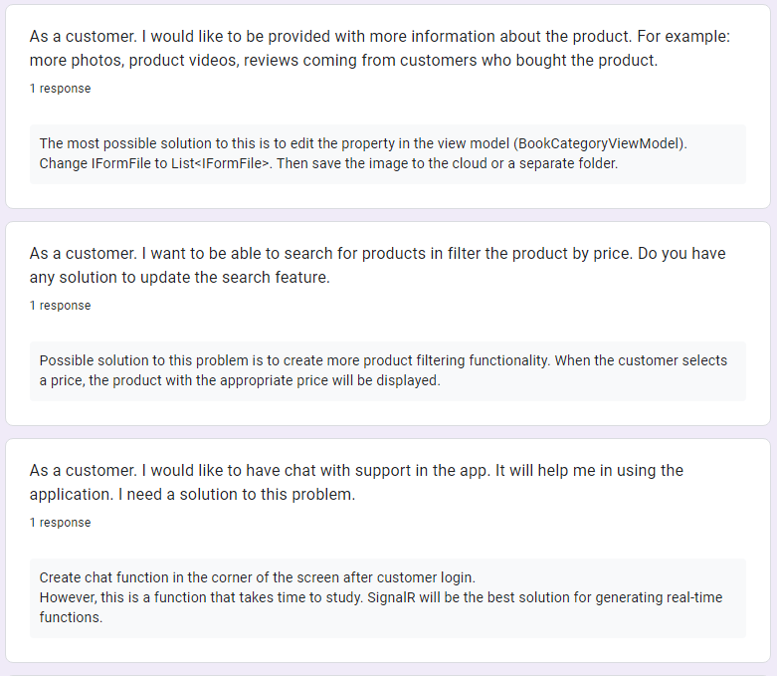

Figure 2: Collect review feedbacks

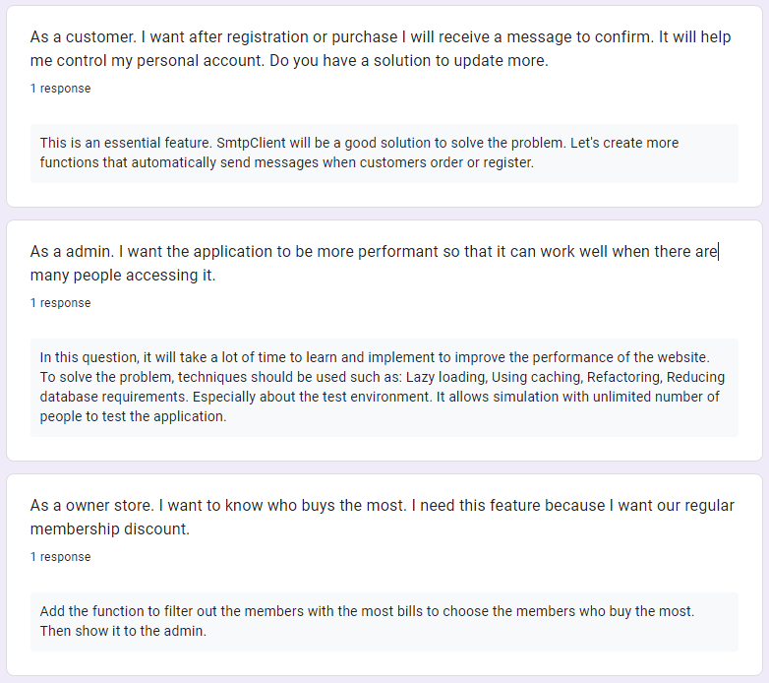

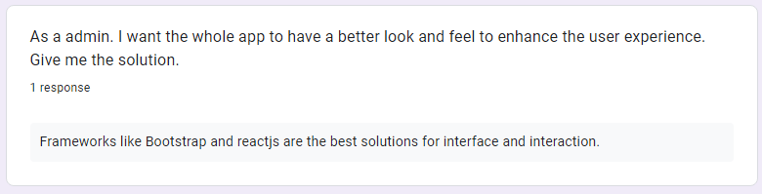

Figure 3: Collect review feedbacks

## **Interpret peer-review feedbacks.**

#### 1) As a customer. I would like to be provided with more information about the product. For example: more photos, product videos, reviews coming from customers who bought the product.

#### According to the answers in the survey: The most possible solution for this is to edit the property in the view model (BookCategoryViewModel). Change IFormFile to List<IFormFile>. Then save the image to the cloud or a separate folder.

#### First: We need to find the file containing the BookCategoryViewMode class. Next we will change the IFormFile property to List<IFromFile>. This will help us to add multiple photos to the app at once. Then we will run a loop to retrieve each file in the list and change the name of the file according to a certain standard.

#### Finally we will get the path. For example (Link to a folder in the Cloud or a folder in the project to store images of the product).

#### 2) As a customer. I want to be able to search for products in filter the product by price. Do you have any solution to update the search feature.

#### According to the answer in the survey: A possible solution to this problem is to create more product filtering functionality. When the customer chooses a price, the product with the right price will be displayed.

#### In the source code we will proceed to get the data from the client side. When the customer selects the product price, the system will run a loop to filter out the products that are equal or low in difference from the price requested by the customer.

#### Finally, the system will send a list of products to look for to the customer's interface. This is a very simple way to deal with the problem.

#### 3) As a customer. I would like to have chat with support in the app. It will help me in using the application. I need a solution to this problem.

#### According to the answers in the survey: Create a chat function in the corner of the screen after the customer logs in.However, this is a function that takes time to research. SignalR will be the best solution for generating real-time functions.

#### Regarding the chat box function, we are still in the learning and testing phase. As far as we know, SignalR handles connection management automatically, and allows messages to be sent to all connected clients simultaneously, like a chat room. You can also send messages to specified clients. The connection between the client and the server is persistent, unlike the classic HTTP connection, which re-establishes the connection for each communication.

4) As a customer. I want after registration or purchase I will receive a message to confirm. It will help me control my personal account. Do you have a solution to update more.

#### According to the response in the survey: This is a necessary feature. SmtpClient will be a good solution to solve the problem. Let's create a function to automatically send messages when customers place an order or register.

#### Regarding the function of sending authentication messages, we are still in the learning and testing phase. As far as we know, the .NET Library provides the SmtpClient class that allows you to send Emails through the SMTP (Simple Mail Transfer Protocol) protocol, the function of the SmtpClient is to transfer the Emails to the SMTP server for this server to do the work forward the email to the recipient's address.

#### Once you have the SmtpClient object, you can transfer the email by editing the email content with the MailMessage class object and then calling the SendMailAsync method of the SmtpClient to transfer.

#### 5) As a admin. I want the application to be more performant so that it can work well when there are many people accessing it.

#### According to survey response: In this question, it will take you a lot of time to learn and do to improve the performance of your website. To solve the problem, it is recommended to use techniques such as: Lazy loading, Using caching, Refactoring, Reducing database requirements. Especially about the test environment. It allows simulation with unlimited number of people to test the application.

#### These are techniques that we have not yet been able to implement. However, as far as I know: the survey respondents suggested that we should reduce the request to access the database and limit the use of ToList() to help the application perform better. In addition, loading many images at once will reduce the performance of the website. We should use slow loading technique and use caching to store images that will help the site load faster when website load again. Furthermore, there are advanced recommendations such as splitting source code files to do one file per task and using javascript files to test the application.

#### 6) As a owner store. I want to know who buys the most. I need this feature because I want our regular membership discount.

#### According to survey responses: Add filter function to members with the most bills to select the members who buy the most. Then show it to the admin.

#### This is a pretty simple function. In this function we will proceed to get the entire customer account. We do this because in each account we have archived 1 order list. We will then proceed to sort the accounts based on the number of order lists.

#### Thus, when the store owner wants to find the person with the most purchase invoices, just choose the sort function to find the person with the most invoices.

#### To make the system more realistic, we will also add a function that sorts users by the total amount spent to purchase the product. To implement this function, I will retrieve detailed invoice objects by account ID. Then sum them together and I get the total amount the customer bought. Then will show to the shop owner.

#### 7) As a admin. I want the whole app to have a better look and feel to enhance the user experience. Give me the solution.

#### According to survey response: Frameworks like Bootstrap and reactjs are the best solutions for interface and interaction.

#### These are the frameworks that we already know about and are learning about them. We will apply them more to the application in the future.

# Chapter 2 – Application Development

## **Folder structure of the application**

#### 

Figure 4: Folder structure

#### - Areas: The Account folder is used to save the scaffolded item of the login and registration page.

#### - Controller: is a directory for files that perform the task of transporting data to the View and contains functions for handling data and manipulating the database.

#### - Data: contains a directory called migration. in the migration contains files with code snippets to save changes from the code to map to the database.

#### The data also contains the file applicationDbContext. This is an important class for the entity framework. This is the bridge between the feature classes and the database. In addition, AppDbContext also has tasks such as: converting LinQ queries into SQL queries coming to the database. Perform Insert, Update, and Delete operations. Finally is the mapping of objects: Convert raw data into object entities.

#### - DTOs: is a directory containing code files whose task is to encapsulate data to transfer from client to server and vice versa. The purpose of creating a DTO is to reduce unnecessary attributes of entities and increase security for the application.

#### - Enums: The files in the enums directory are used to declare a collection of enumerations (Enumeration). An enumeration is a set of user-defined constants. Ex: used for the status of the order.

#### - Models: Model is a collection of application classes that can contain additional logic. These classes are used to implement entities based on that class and to store the application's data. In addition, they are also used to map to the database through the entity framework.

#### - Utils: This directory contains a file containing the constants representing the system roles.

#### - ViewModels: This folder also contains files similar to DTOs.

#### - Views: This folder contains files used to display information on the client side.

## Source code samples of the application with explanation.

### Orders Controller:

#### The Orders Controller file in the system is used to perform actions like CRUD with orders. However, to use the functions from this controller, the user needs to be successfully logged in.

#### In this controller there are properties like:

#### - Context: contains lists based on data types that are classes for storing system objects. For example: Dataset<Order> orders.

#### - UserManager: store and manage all system accounts.

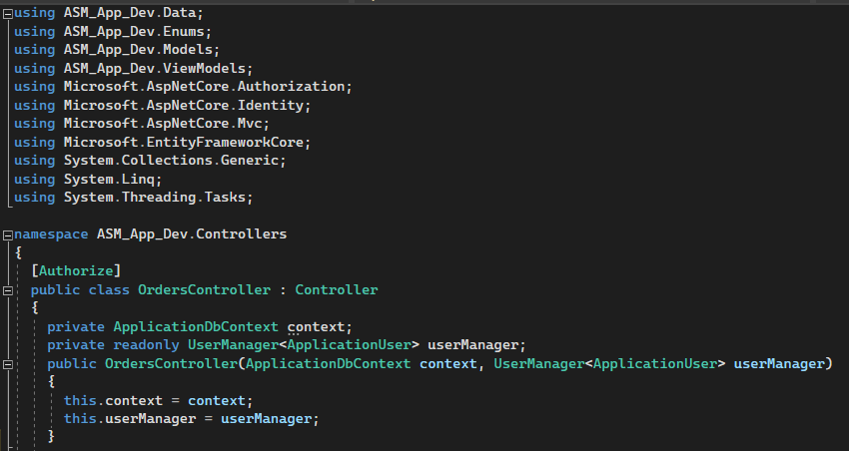

Figure 5: Orders Controller

#### **Method Index:** used to display all user orders by ID and made by LinQ. When the function works, the entire user's invoice will be pushed by the controller to the view file.

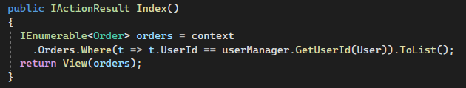

Figure 6: Method Index

#### **Create method:** this function is used to add products to the customer's cart. When user is on home page or product detail page then user can use this function to add product to cart. When the user presses the add to cart button, the system will search for the invoice provided that: the order status is unconfirmed and the UserId of the order is equal to the ID of the current user.

#### - First, If there are no orders that satisfy the above two conditions, the system will create a new order and assign a value to UserID and order status. Next, the system will add a new order to the user's order list. Finally, the system will call the function create detailed order and pass 2 parameters, ID Book and ID Order. After creating the order item, the system will automatically call the GetPriceOfOrder function to recalculate the total amount of the current order.

#### - Second, If there is an order in the database that satisfies the 2 conditions of unconfirmed status and of the current user, the system calls the create order detail function to add the product to the cart and then calculates total value of the order.

#### After performing the above dynamic rows, the context property will be called to save what changes. This is an HttpGet function. However, it will not return any page views, it will call another function in the OrderDetails controller. The system will return the shopping cart page for the user to view.

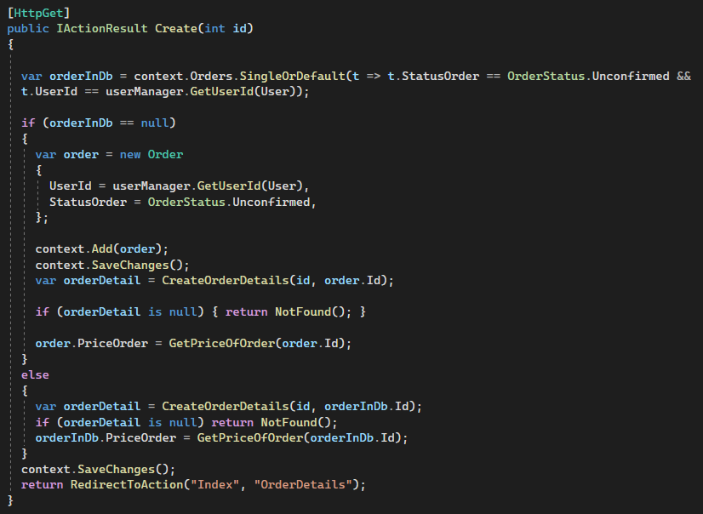

Figure 7: Create method

#### **GetPriceOfOder method** is used to calculate order value by detailed order list by order ID. It will use a loop to iterate from the item in the list and add up the value of each item.

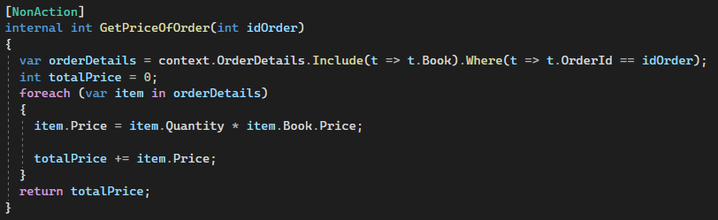

Figure 8: GetPriceOfOder method

#### **CreateOrderDetails method** will perform the task of adding products to the cart. Before adding a product to the cart, we will need to check the quantity of that product. If the quantity of the product is greater than 0, there will be 2 cases:

#### First, the system will search the "order item" object to find the object whose Order ID and Book ID are equal to the passed argument. If not found, the system creates an object based on the OrderDetail class. Then will save the newly initialized object to store the necessary data.

#### Second, If the system finds a matching OrderDetail, it will add 1 unit to the product quantity attribute. Then will proceed to recalculate the price of that OrderDetail.

#### 

Figure 9: CreateOrderDetails method

#### **Edit Method in Order Detail Controlller:**

#### Before talking about the checkout function, we need to discuss a little bit about the Edit function in the order detail controller. To reduce requests to the database, I will save the quantity of all products in the cart when the customer presses the purchase button. With the parameter passed as an instance of the cart class. This function will be responsible for checking and saving the number of products that the customer has edited in the cart and calling another action in the order controller.

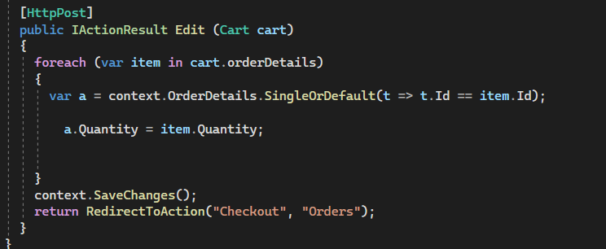

Figure 10: Edit Method in Order Detail Controlller

#### **Checkout method** will be used for the task when the customer wants to go to the checkout screen. We have a view model checkout class to assist with this task. When the function works, a new entity will be created by the checkout class. Then it will assign the necessary attributes such as name, address, phone number. Then it will look up the invoice with the unpaid status to process it. The foreach loop will have the task of running each item in the list with the purpose of subtracting the number of books sold.

#### Then the system will recalculate the order value. We also can't forget that after each function operates, it is necessary to save them in the database.

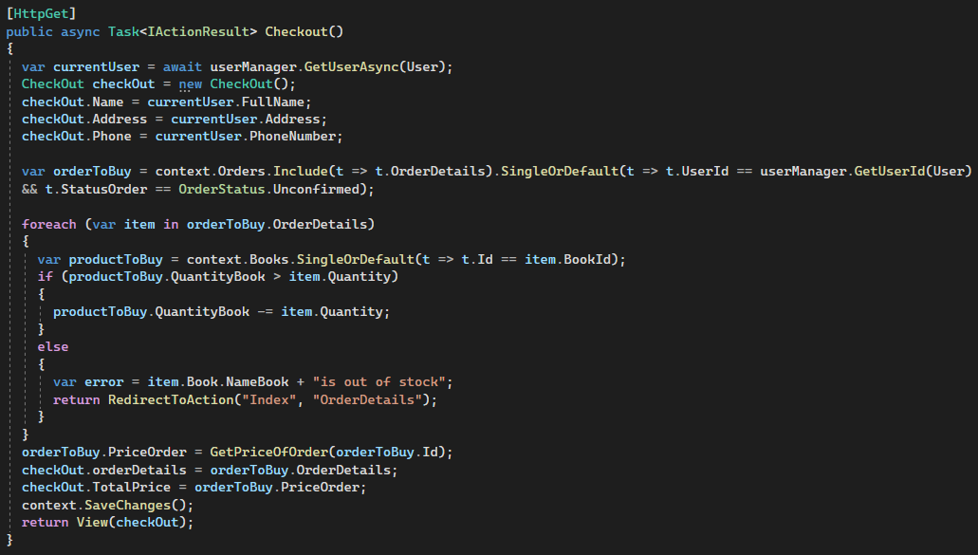

Figure 11: Checkout method

#### Finally, the **Purchase Function** is active when the customer is on the checkout page and presses the purchase button. The system will retrieve the order with an unconfirmed status and change the status to processing. Will then save it in the database and pass it to the Index action in the Order Controller.

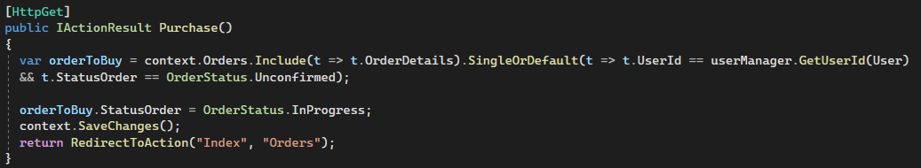

Figure 12: Purchase Function

### ApplicationDbContext:

#### Application Db Context is an important class for entity framework. This is the bridge between the classes and the database. In addition, AppDbContext also has tasks such as: convert LinQ queries into SQL queries to the database. Perform Insert, Update, and Delete operations. Finally, the mapping of objects: Convert the raw data into object entities. This class contains functions like SeedRoles to push data to the database from the source code. In addition, this class also contains 4 db sets to store many application objects.

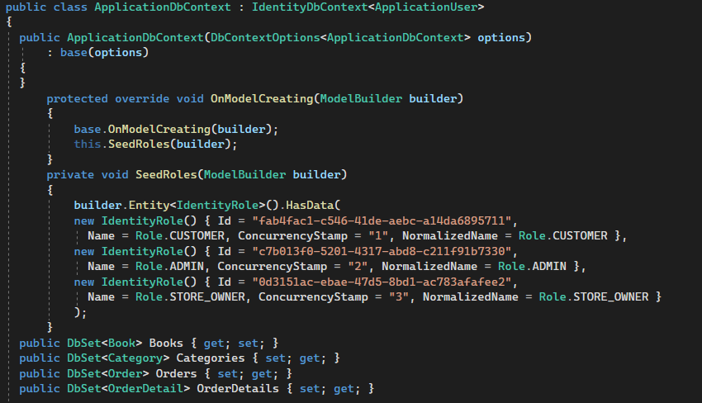

Figure 13: ApplicationDbContext

### DTOs (Data transfer object):

#### DTOs is a directory containing code files that are responsible for packaging data to transfer from the client to the server and vice versa. The purpose of creating a DTO is to reduce unnecessary attributes of entities and increase the security of the application. In this book view class will have the necessary properties to display to the customer. This Model View will be used in the home page and product detail page.

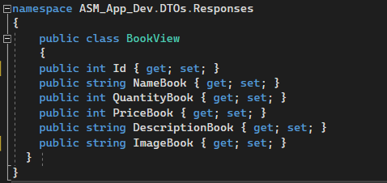

Figure 14: DTOs (Data transfer object)

### Enums (Enumerated type):

#### Enums: Files in the enums directory used to declare a set of enumeration types (Enumeration). An enumeration is a collection of user-defined constants. For example, used for status of orders and categories. When using enums, their value will be stored as a count from 0 in the enum class. However, when interacting with data, we will use properties in the enum class. (**For example:** In Database: Status Categories = 1. In Source Code and View: Status Categories = InProgress.)

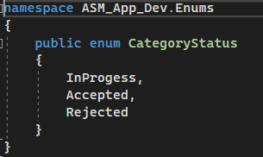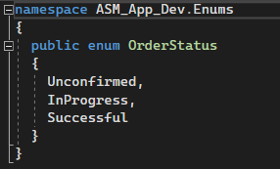

Figure : Enums (Enumerated type)

### Model (Order & Order Detail):

#### Following are 2 of 5 models of our program. Class order will be used to store the data of an invoice. Order Class: ID,User ID, User, Date Order, Price Order, Status Order, List <Order Detail>.

#### The Order Detail class is used to store and display the detailed lines in the invoice. This class was created to solve the many-to-many relationship between the order and book classes. In the Order Detail class, there will be properties such as: ID, Order ID, Order, Book ID, Book, Quantity, Price.

#### These 2 classes will have a one-to-many relationship.

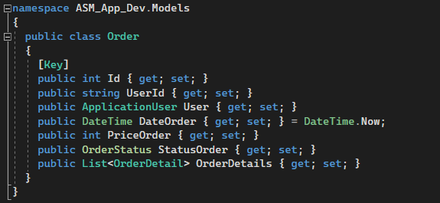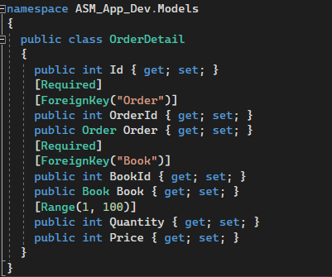

Figure 16: Model (Order & Order Detail)

### View Model (Cart & Check Out)

#### The class in the View Model folder is the same as the class in the DTOs folder. They share the same task is to display the necessary information to the user. These 2 classes are used as cart page and checkout page respectively. However, in the cart class, we will label it as [Bind Property]. This we will apply for the purpose when using this class to send data to the database from an HTML file. Bind Property will map the properties in the view to the model in use.

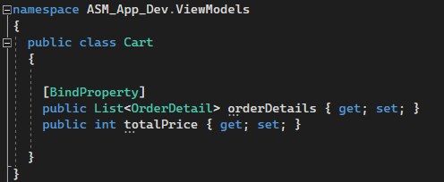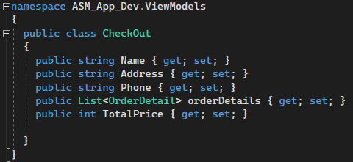

Figure 17: View Model (Cart & Check Out)

### View (Cart, Home Page)

#### Here are 2 examples of cshtml files. These 2 files are used to build and structure the content of a website. We built it and used it with bootstrap 5 and css to render the interface suitable for the user. In the cshtml file we have used loop to display a list of objects. Finally, we've also used conditionals to be able to display something when a given condition is met.

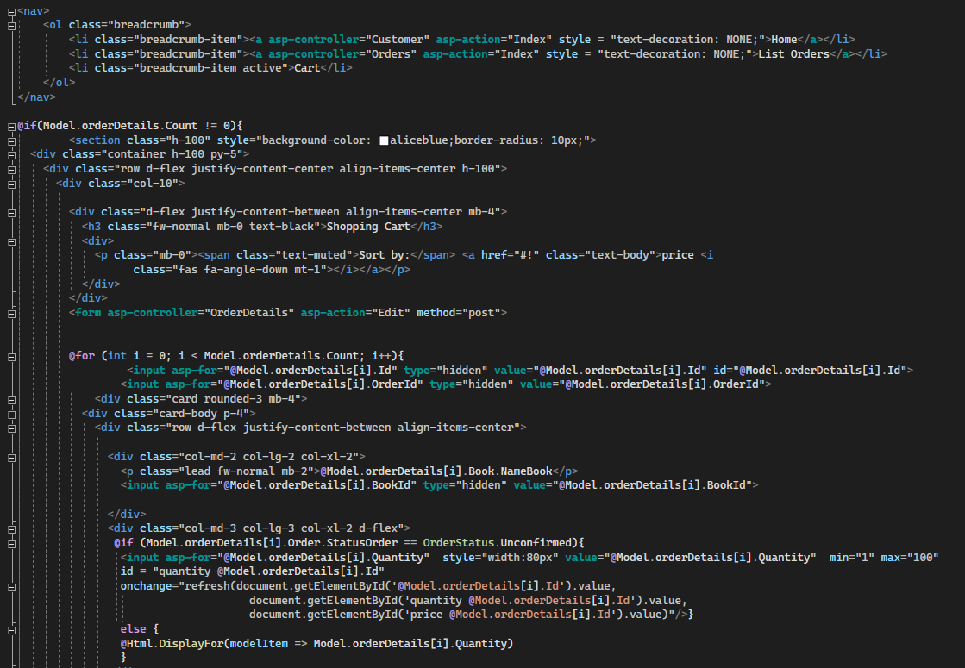

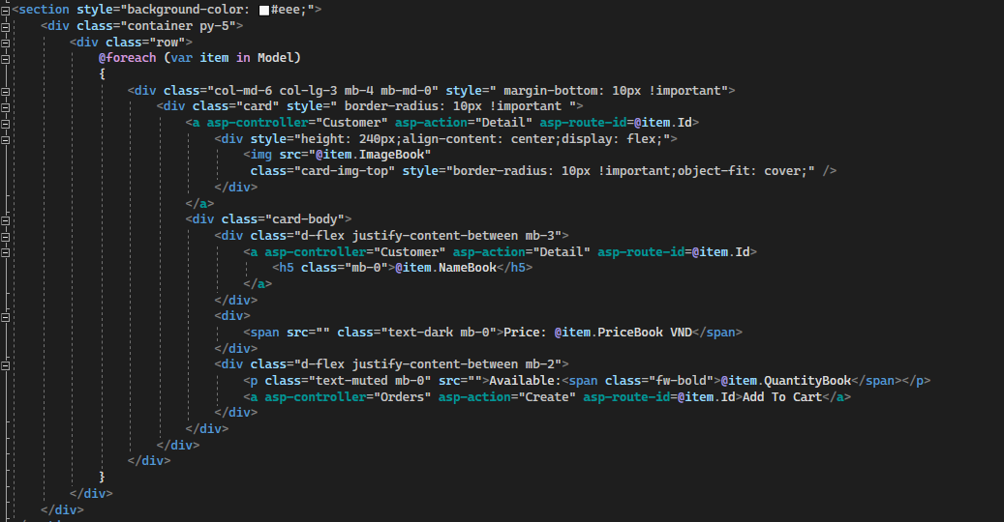

Figure 18: View (Cart, Home Page)

### Css (Detail Product):

#### The following is a small code example of the language used to format HTML elements.

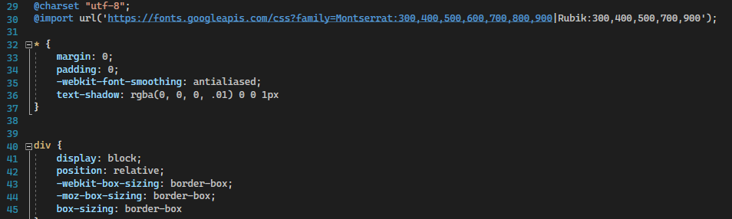

Figure 19: Css (Detail Product)

## Final screenshots of the application.

### Role Admin:

#### Admin Home Page

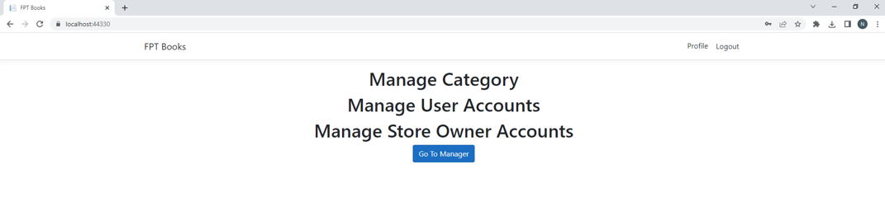

Figure 20: Admin Home Page

#### Admin Page (list all user in Customer & Store Owner role)

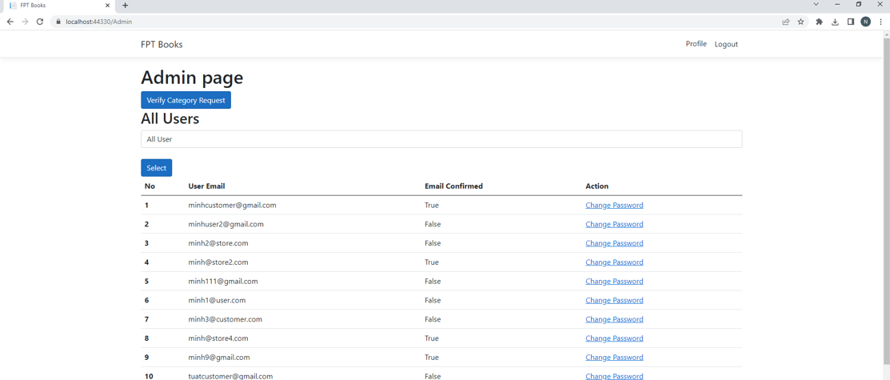

Figure 21: Admin Page (list all user in Customer & Store Owner role)

#### Admin Page (list Store Owner role)

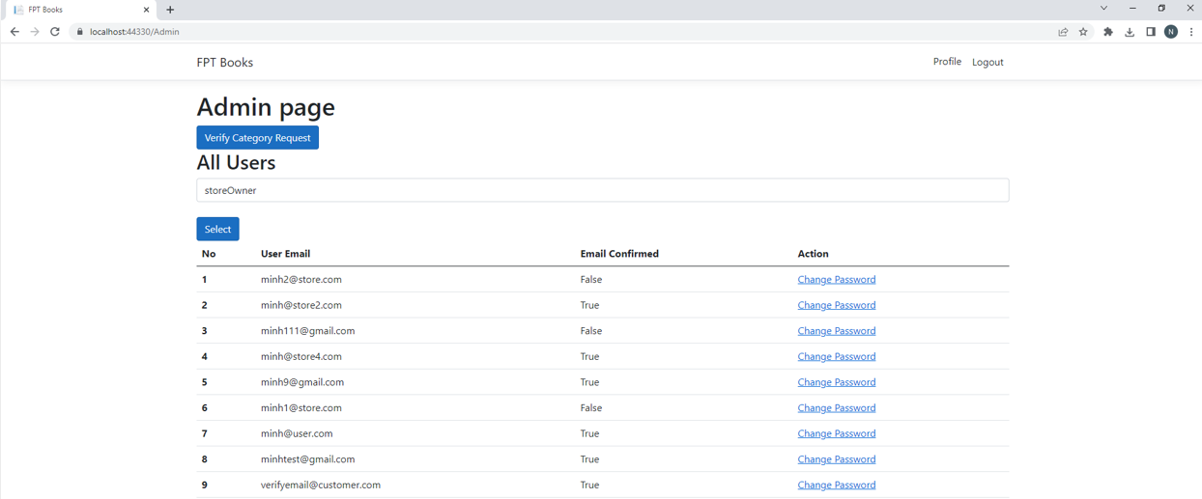

Figure 22: Admin Page (list Store Owner role)

#### Admin page (list customer role)

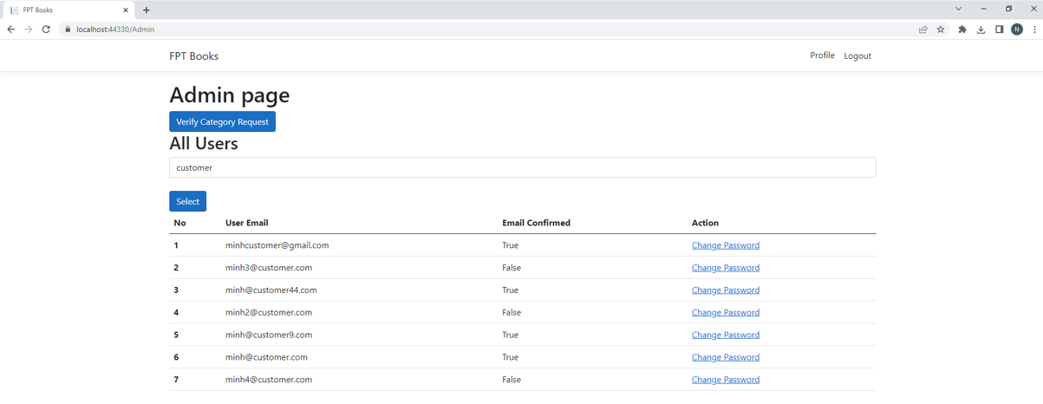

Figure 23: Admin page (list customer role)

#### Change Password

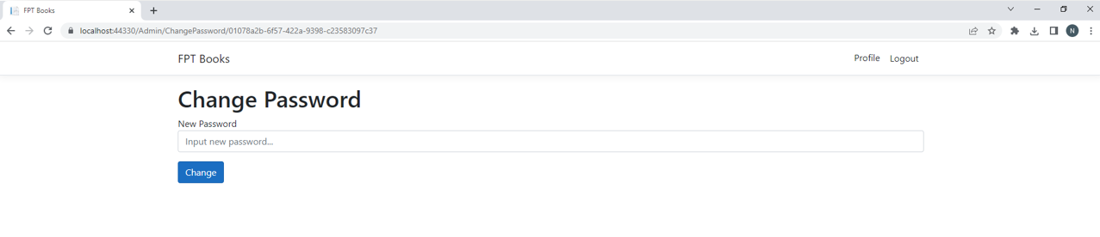

Figure 24: Change Password

#### When change Password successfully

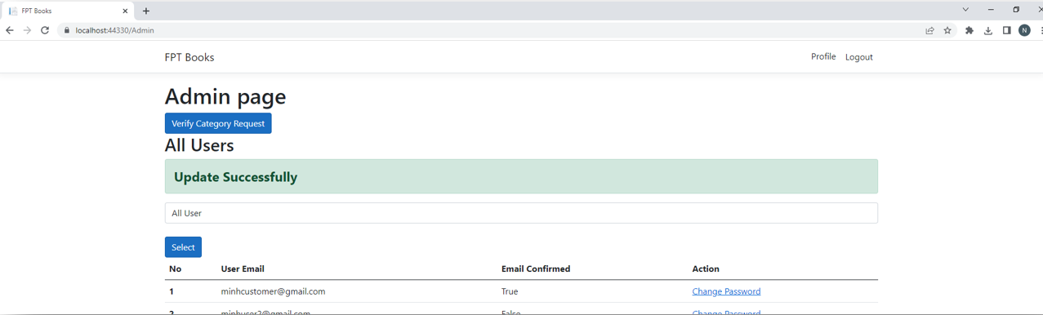

Figure 25: When change Password successfully

#### When select account not confirmed

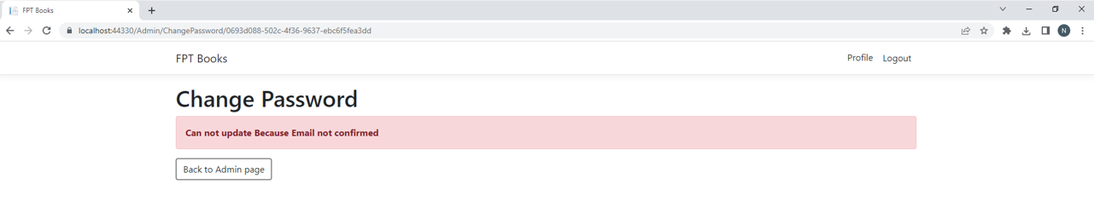

Figure 26: When select account not confirmed

### Role Owner Store:

#### This is the main interface of the store owner. Here they can CRUD Book or switch to the category or order management page.

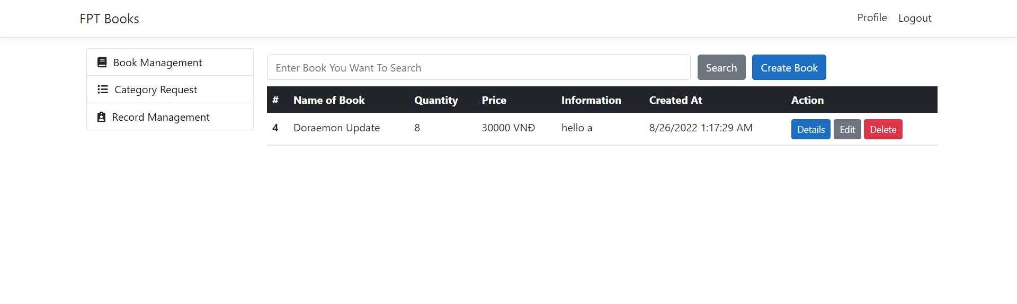

Figure 27: Book Management

#### This is the product detail page.

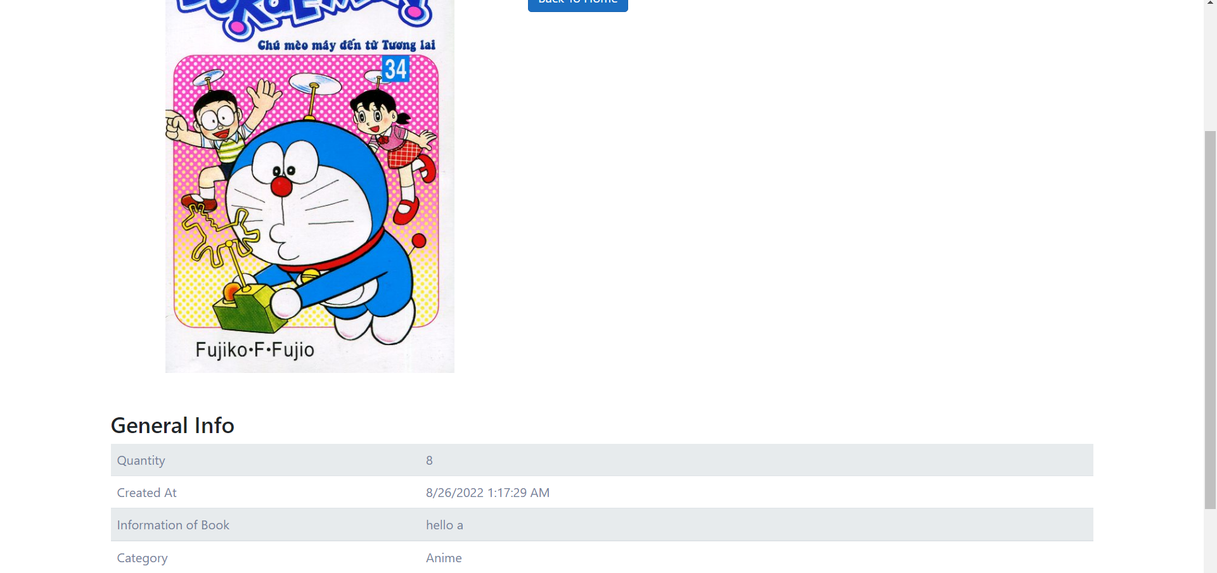

Figure 28: product detail page

#### This is a page that creates books so that they can be sold on the website.

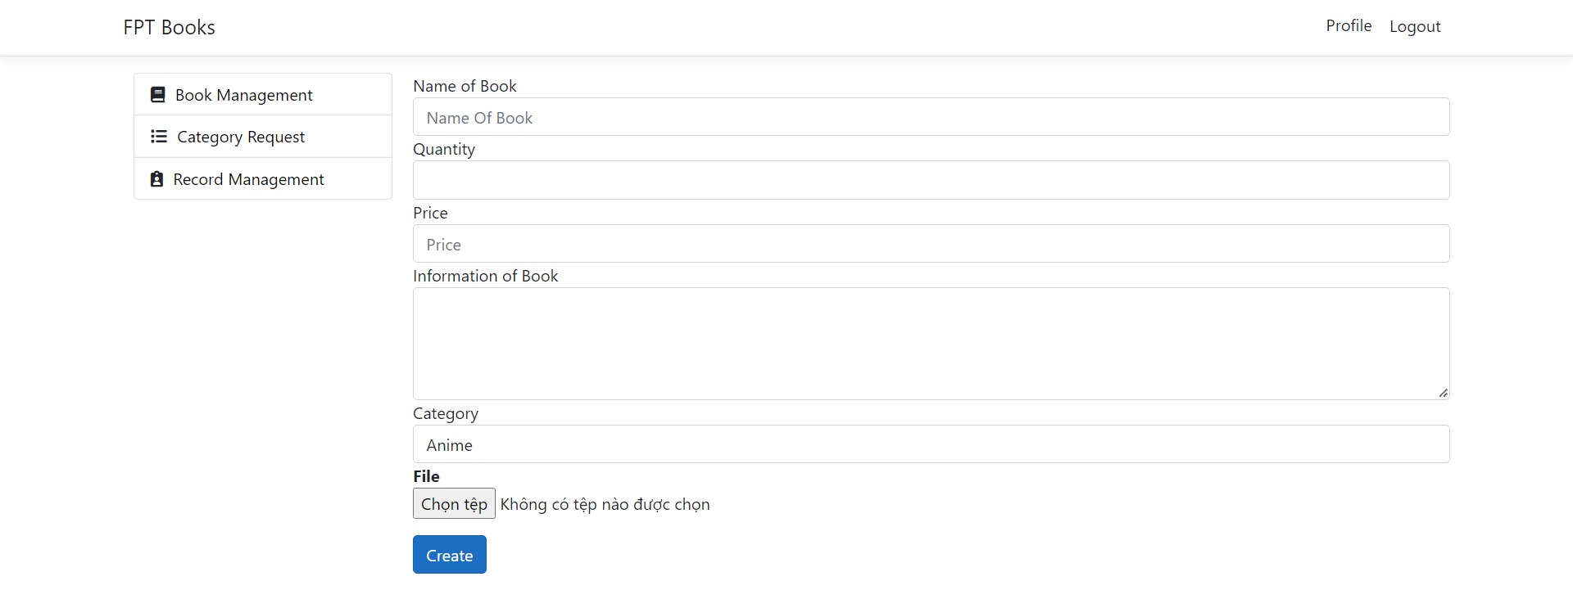

Figure 29: creates books

#### This is the book editing page.

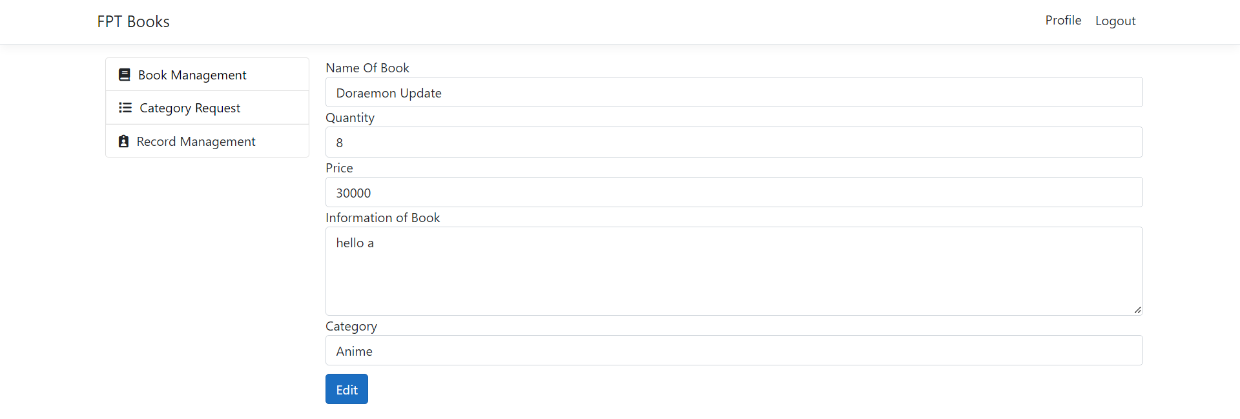

Figure 30: book editing page

#### When in the main interface. Store owners can switch to management category. This is the interface of category management.

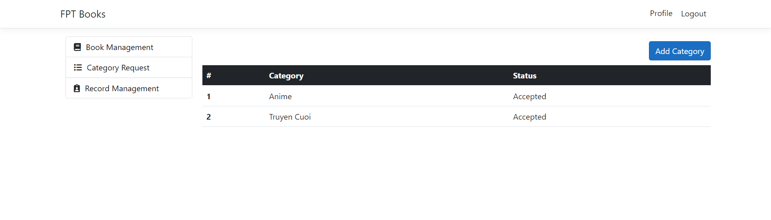

Figure 31: management category

#### This is the category creation page.

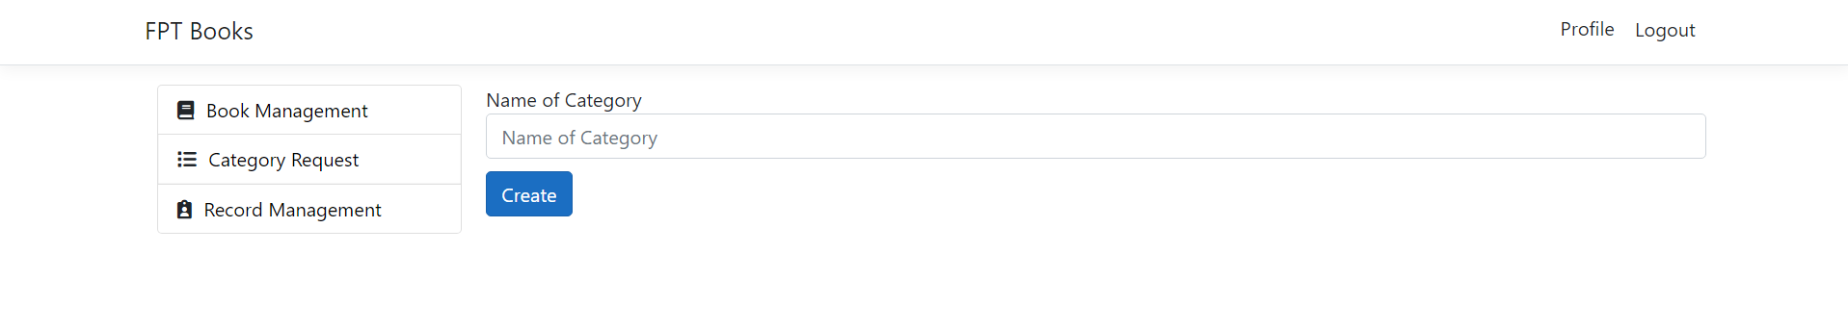

Figure 32: Create Category

#### This is the main page for order management. Here, the shop owner can view the details of an order.

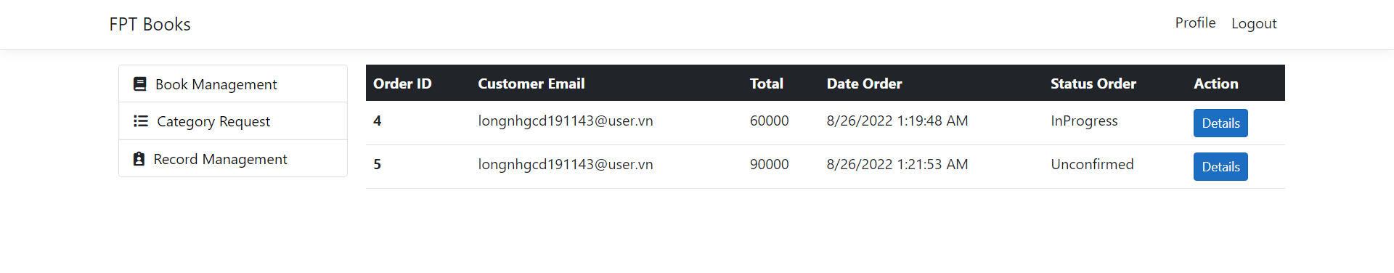

Figure 33: Management Record

#### When clicking on the order details, the system will display more detailed information about the order such as customer name, address, total price and product.

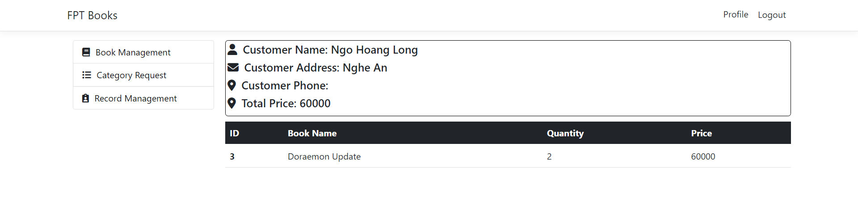

Figure 34: Order Detail Page

### Login Page

#### When using the application, users need to log in to be able to make purchases or perform operations to manage the website.

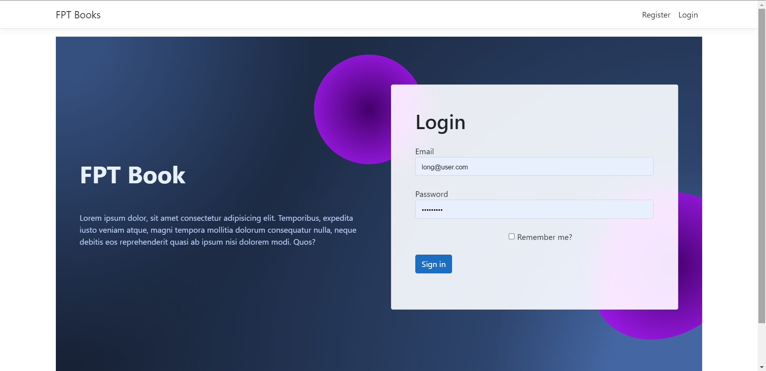

Figure 35: Login Page

### Register Page.

#### When users do not have an account, they can register an account at the registration page.

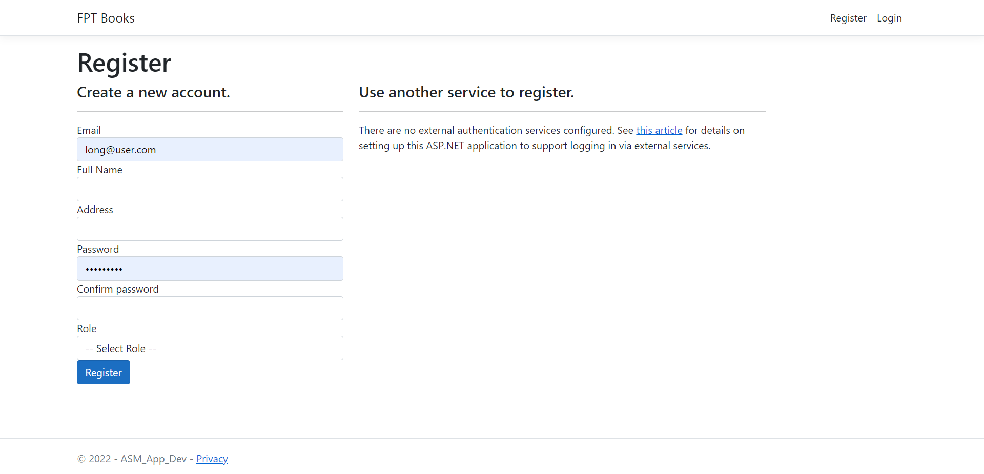

Figure 36: Register Page

### Role Customer:

#### This is the home page of the website. When customers log in, the system will display the home page so that users can perform operations here.

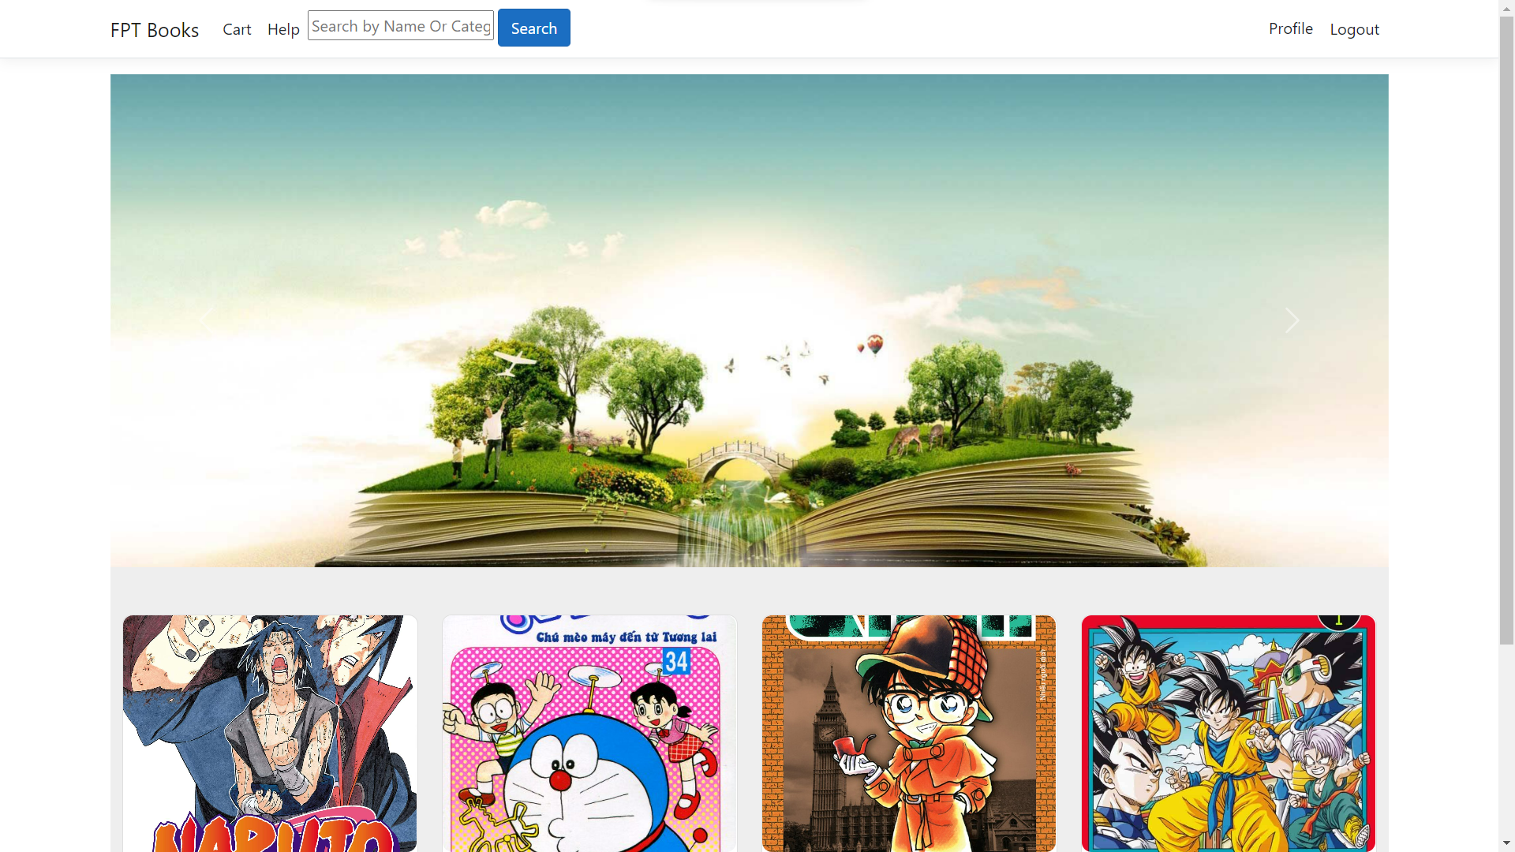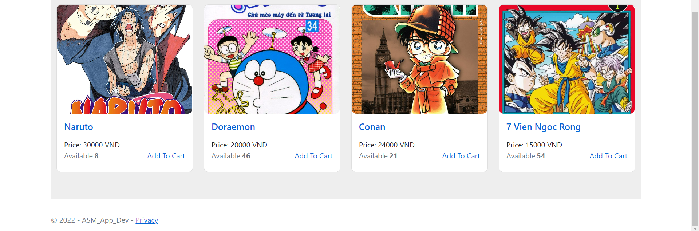

Figure 37: Home Page

#### When the user wants to see more information about the product, this will be the information page for the user.

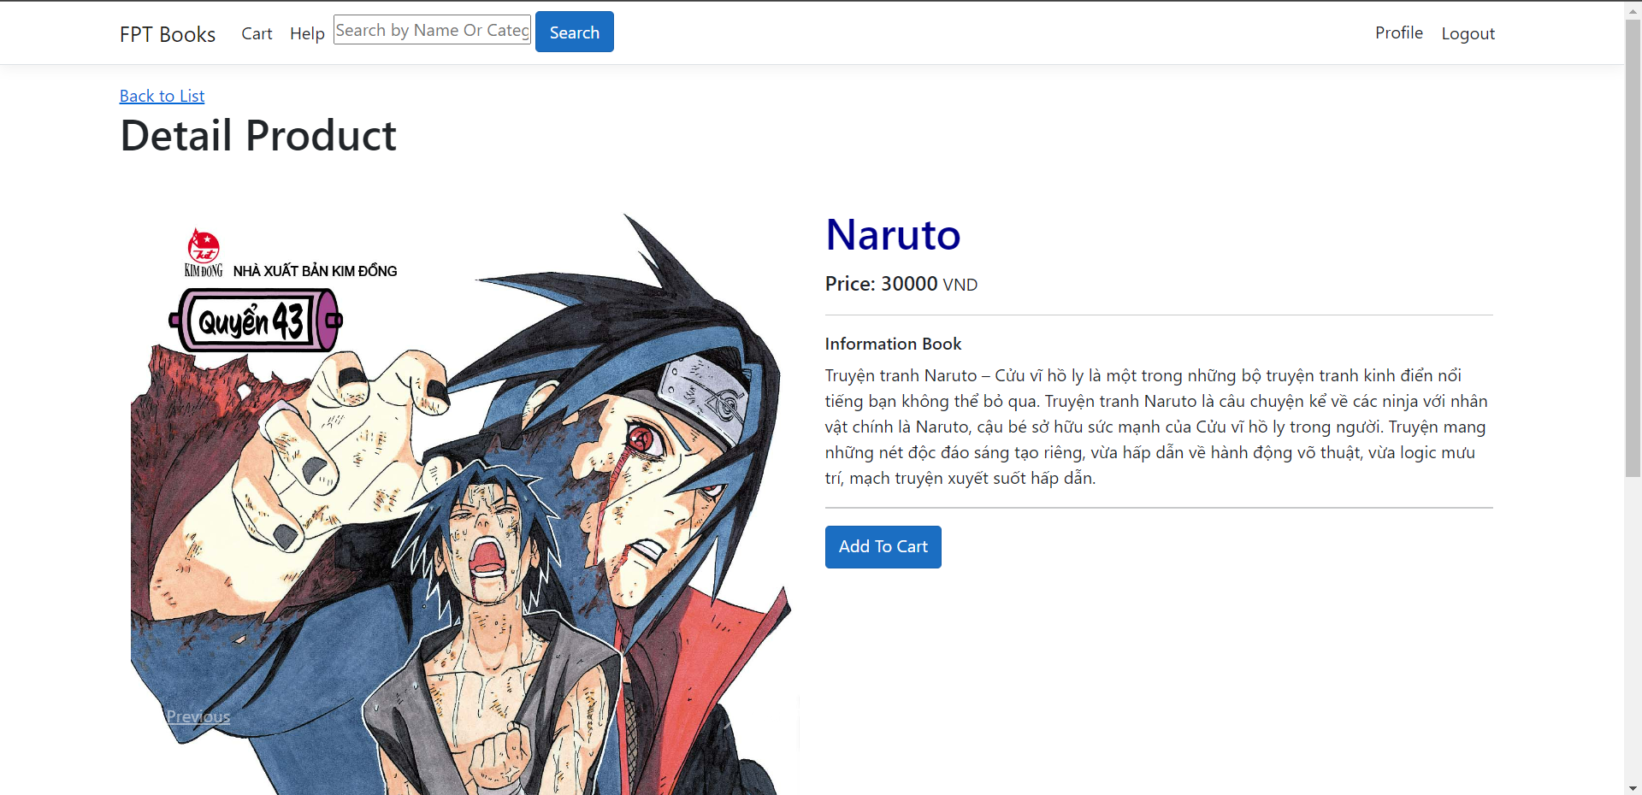

Figure 38: Detail Product Page

#### The shopping cart page will show what the customer has previously selected. Here, users can edit quantity and remove items from cart, view product details, view invoice list. Finally, the customer can press the purchase button to go to the checkout page.

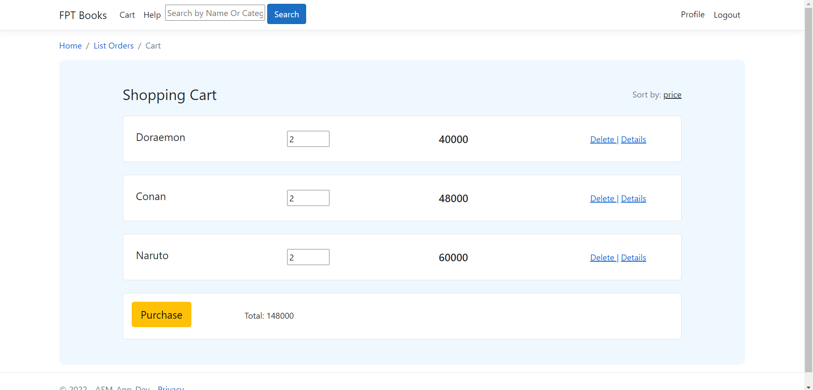

Figure 39: Cart Page

#### This is the payment page, customers will confirm the address, phone number and product along with the quantity before making a purchase.

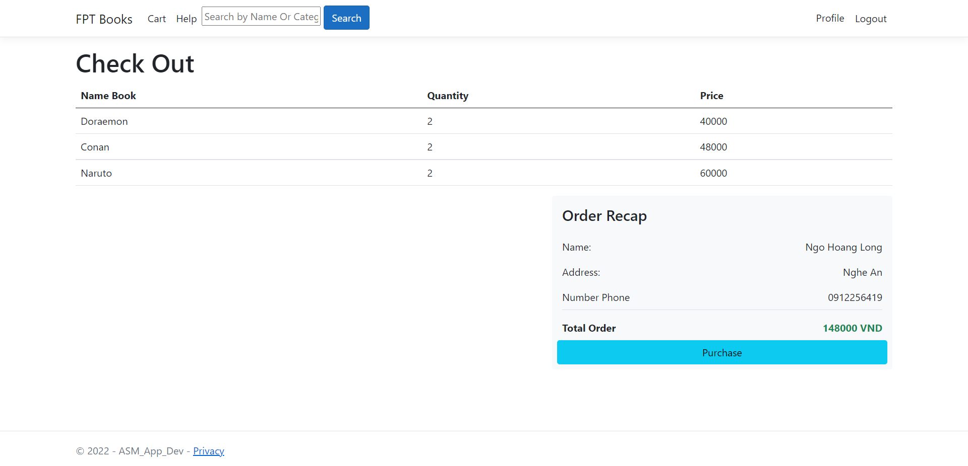

Figure 40: Checkout Page

### Help Page

#### The help page will answer customer questions and problems.

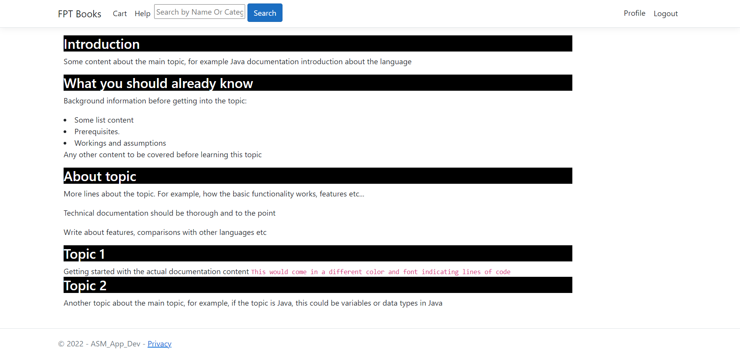

Figure 41: Help Page

## Screenshots of using GitHub or GitLab to manage the source code.

#### These are proof that our team built the website together. You can view the project via the link: <https://github.com/HoangLong9991/ASM_App_Dev.git>

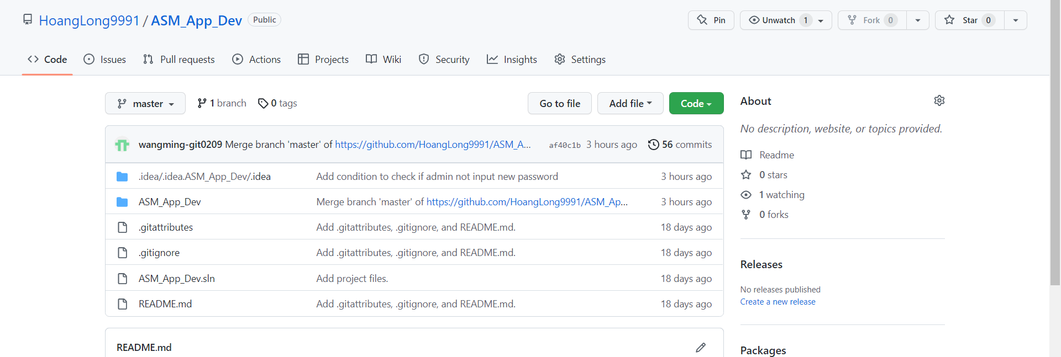

Figure 42: Github

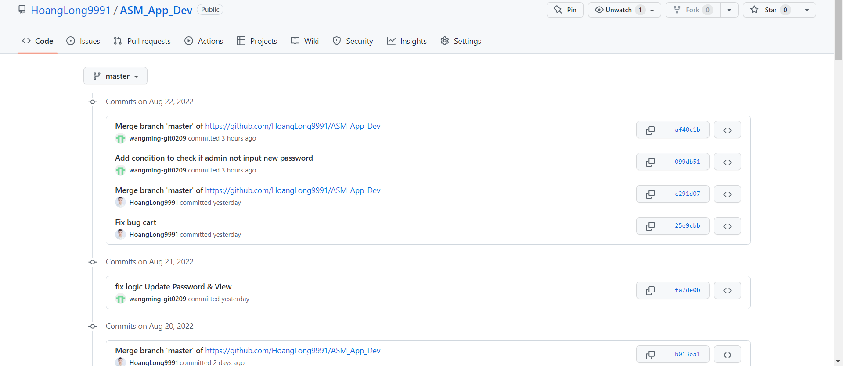

Figure 43: Commit

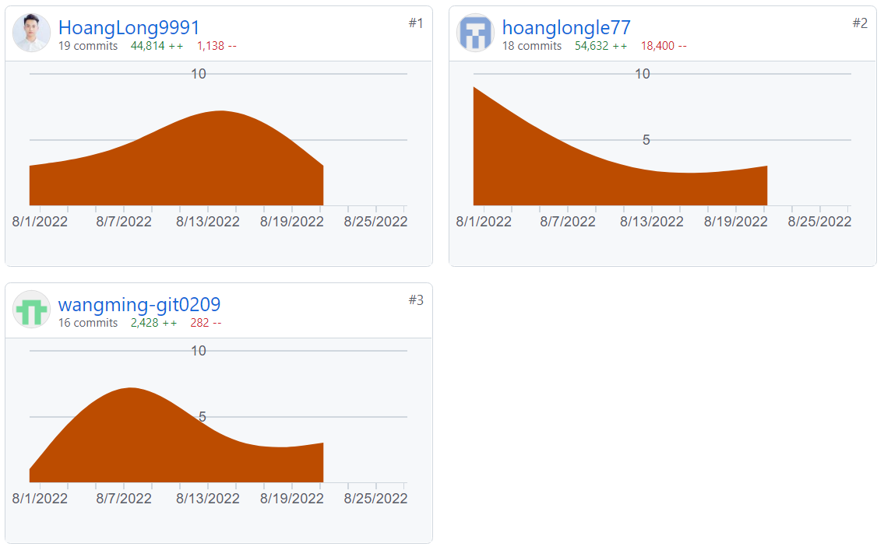

Figure 44: Detail Commit

## Screenshots of using IIS or Azure for the application deployment.

#### To be able to deploy the website, we will first change the database from local to production database. Following are the steps to get the file containing the database structure (Schema) and data from the local database.

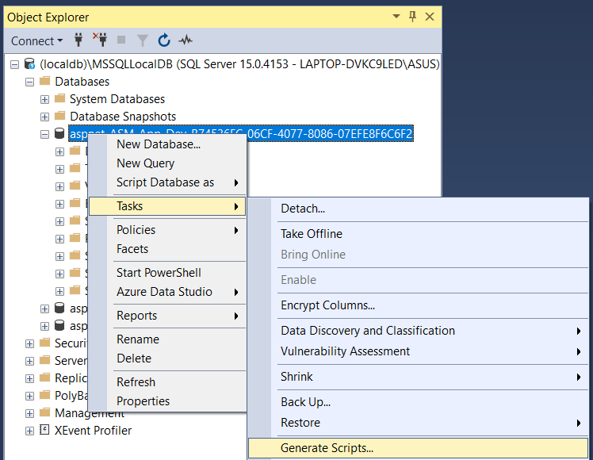

Figure 45: Config SQL Server

#### Select all table in database.

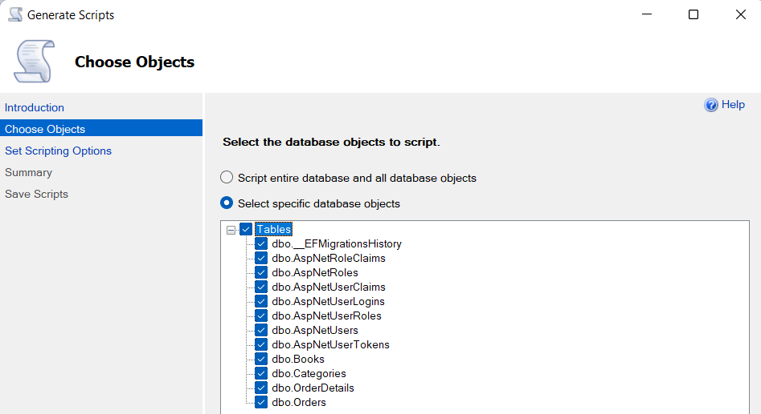

Figure 46: Config SQL Server

#### Select types of data to script: Schema and data

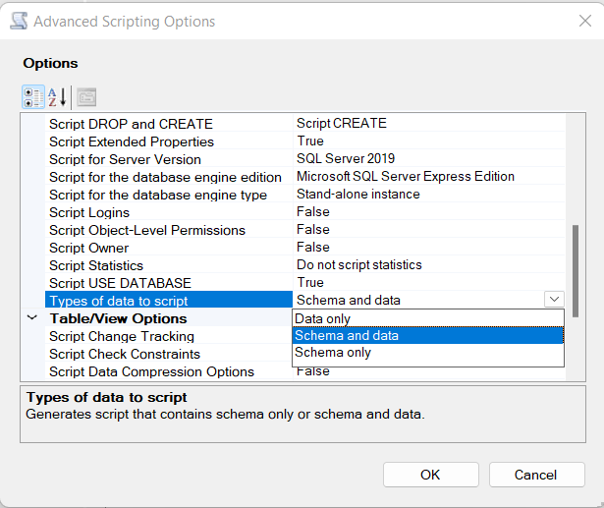

Figure 47: Config SQL Server

#### Choose a save location.

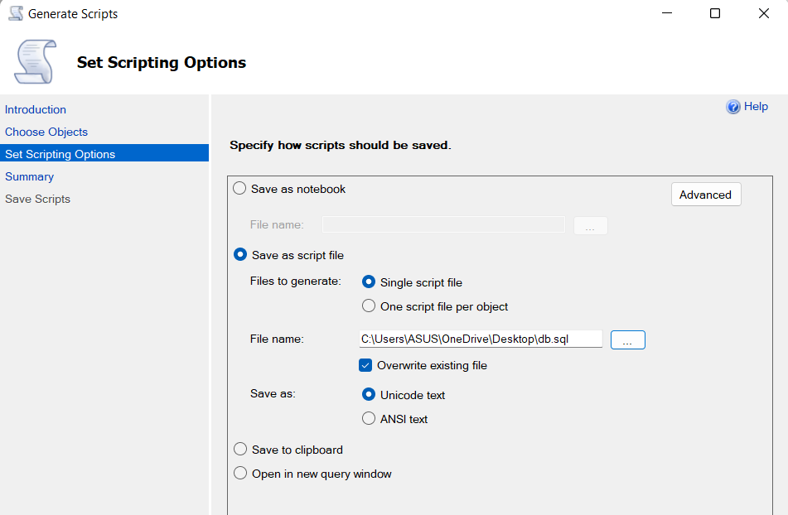

Figure 48: Config SQL Server

#### Success

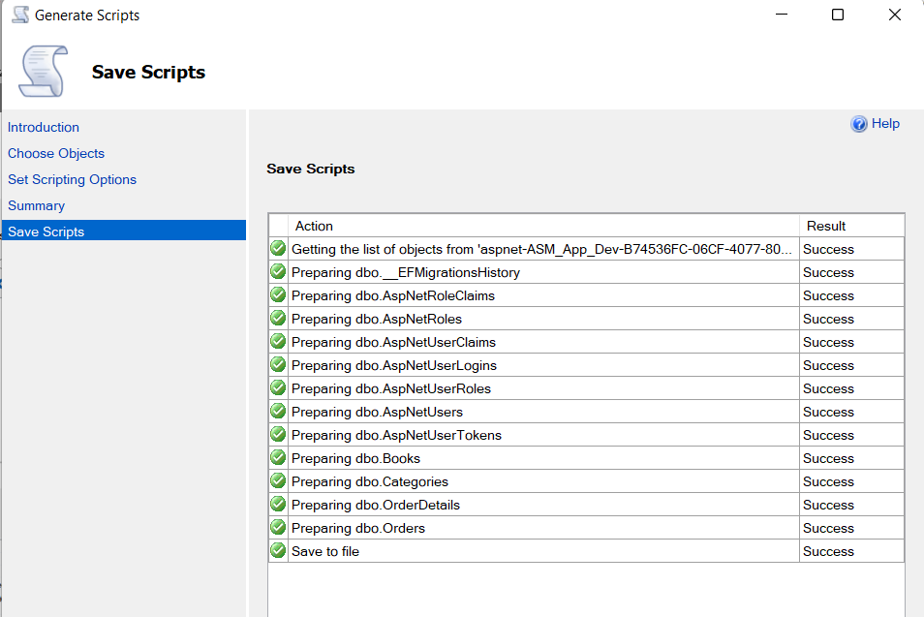

Figure 49: Config SQL Server

#### This is a file containing SQL commands to create tables and insert data into the database.

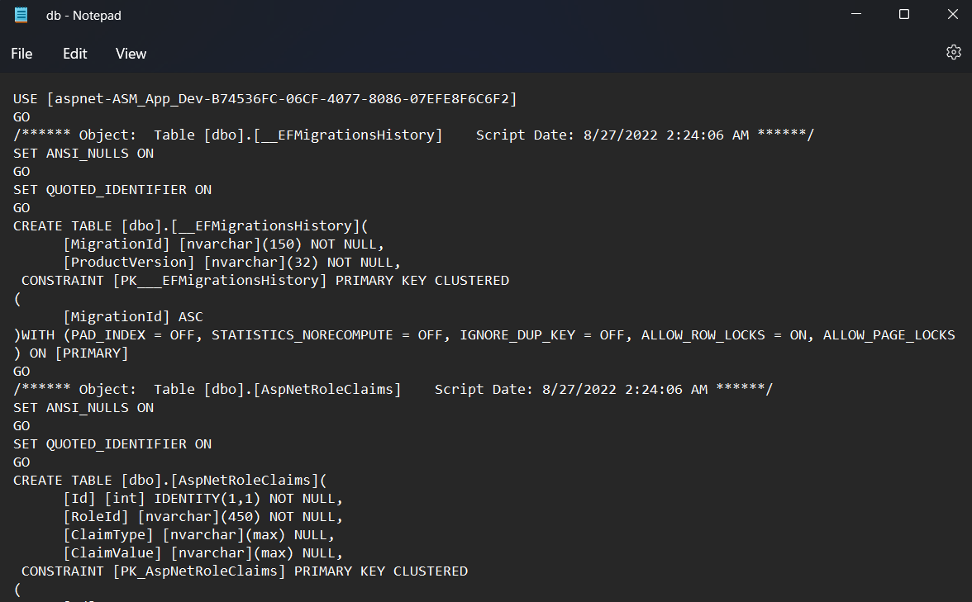

Figure 50: File Config SQL Server

#### Go to the new server and do the database creation.

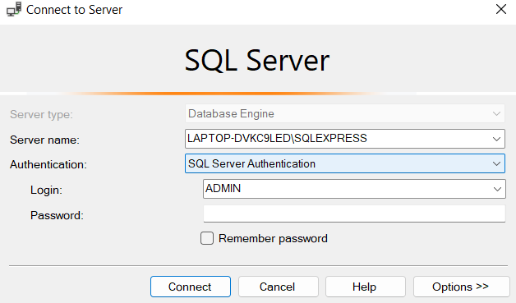

Figure 51: Config SQL Server

#### Create database



Figure 52: Config SQL Server

#### Create table and insert data

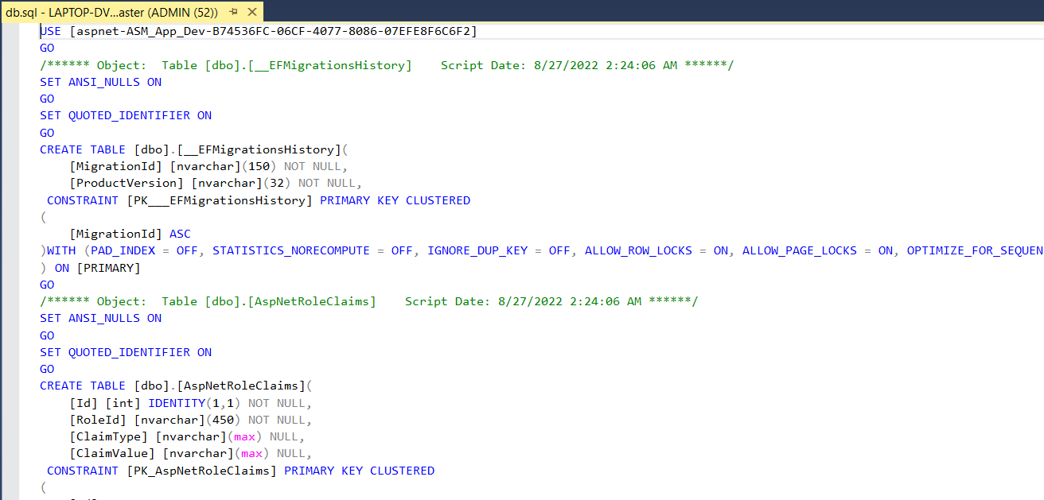

Figure 53: Config SQL Server

#### Check again and this is result.

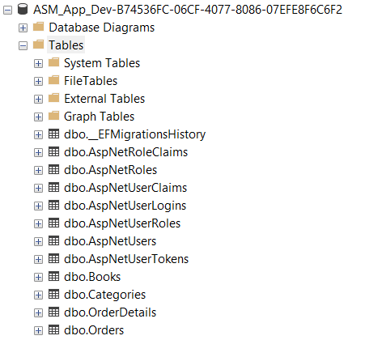

Figure 54: Result Config SQL Server

#### Next will create an account with the purpose of limiting access to the database.

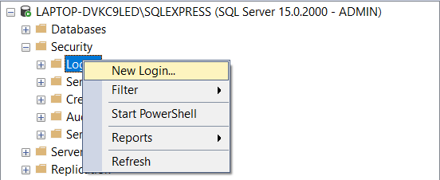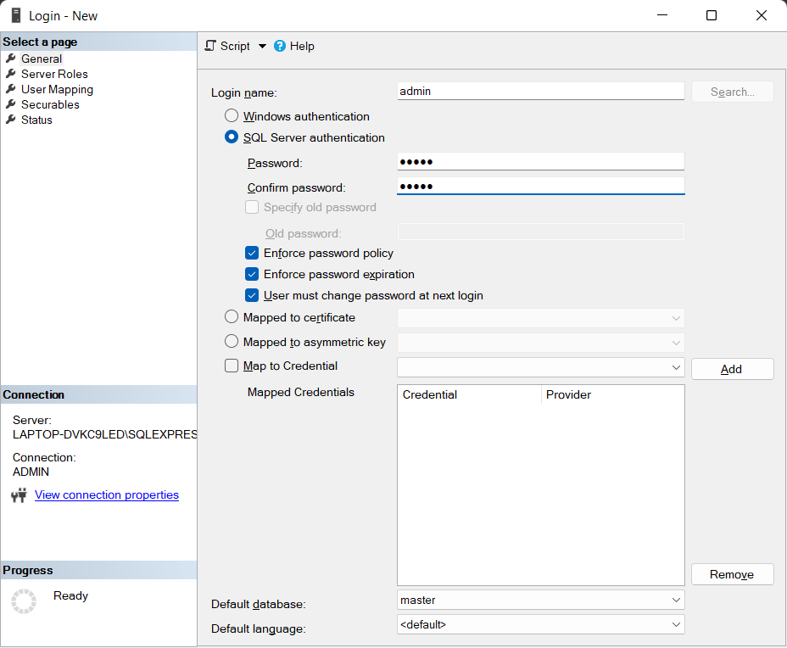

Figure 55: Config SQL Server

#### Then, we head on to check the server roles for the user login credentials.

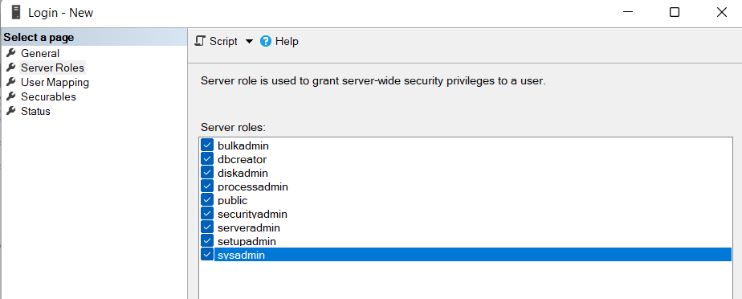

Figure 56: Config SQL Server

#### We need to restart the SQL Server Service for the configuration to be applied to the application database.

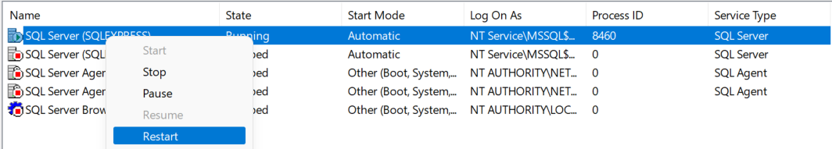

Figure 57: SQL Server Service

#### Add the path and password to allow the website to have access to the database.



Figure 58: Config ConnectString

#### Change the database path and use deploy connection.

#### 

Figure 59: Config ConnectString

#### Next, we will configure IIS Server. Start default web site.

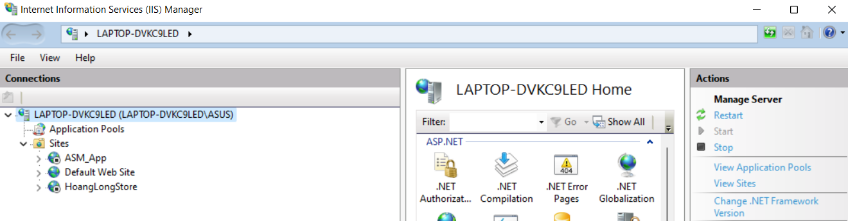

Figure 60: Config IIS Server

#### Right click and select publish.

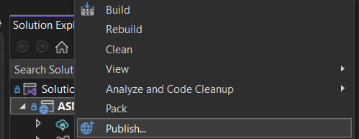

Figure 61: Deploy Website

#### Select the IIS web server.

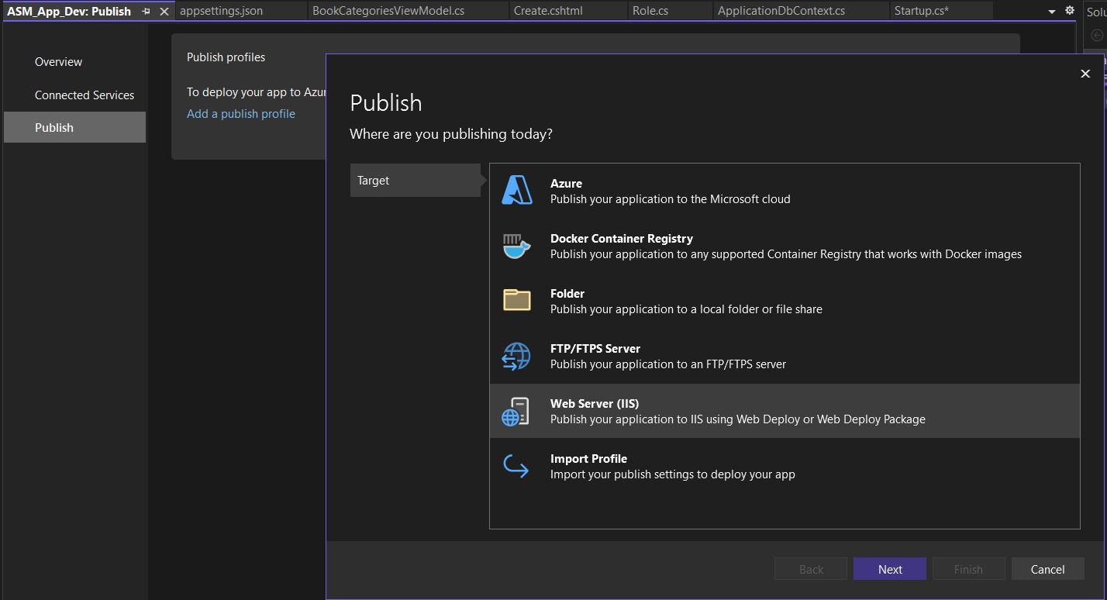

Figure 62: Deploy Website

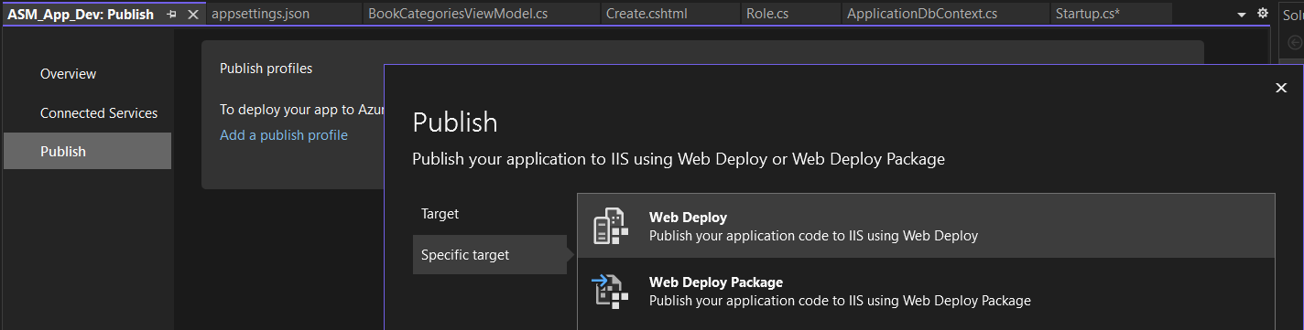

Figure 63: Deploy Website

#### Enter the website name in the IIS server and the website path.

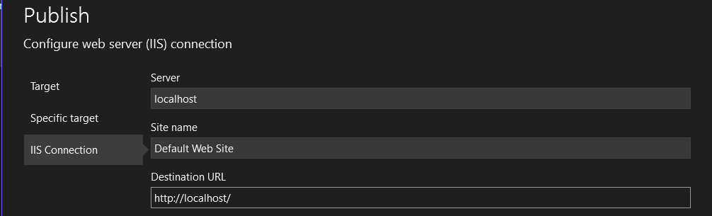

Figure 64: Deploy Website

#### Click publish to Deploy website.

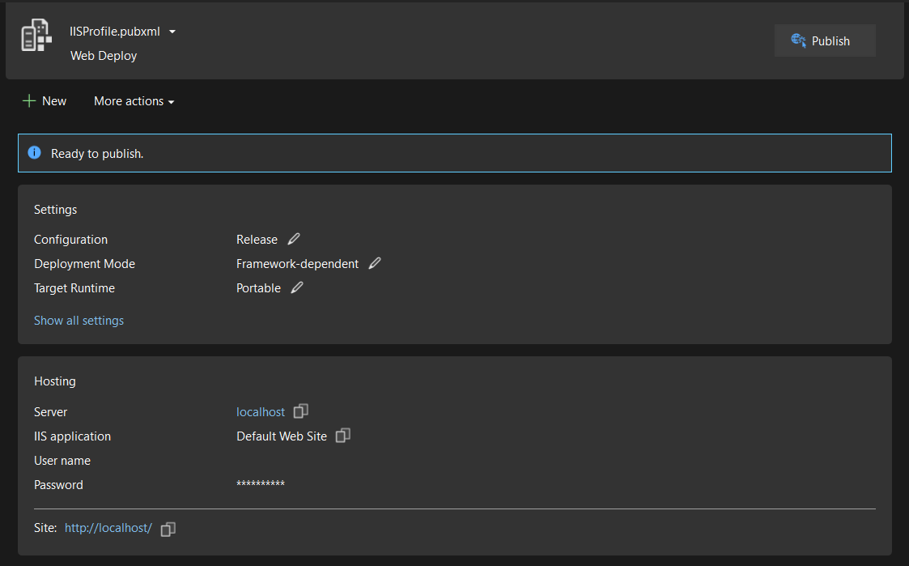

Figure 65: Deploy Website

#### Deploy success

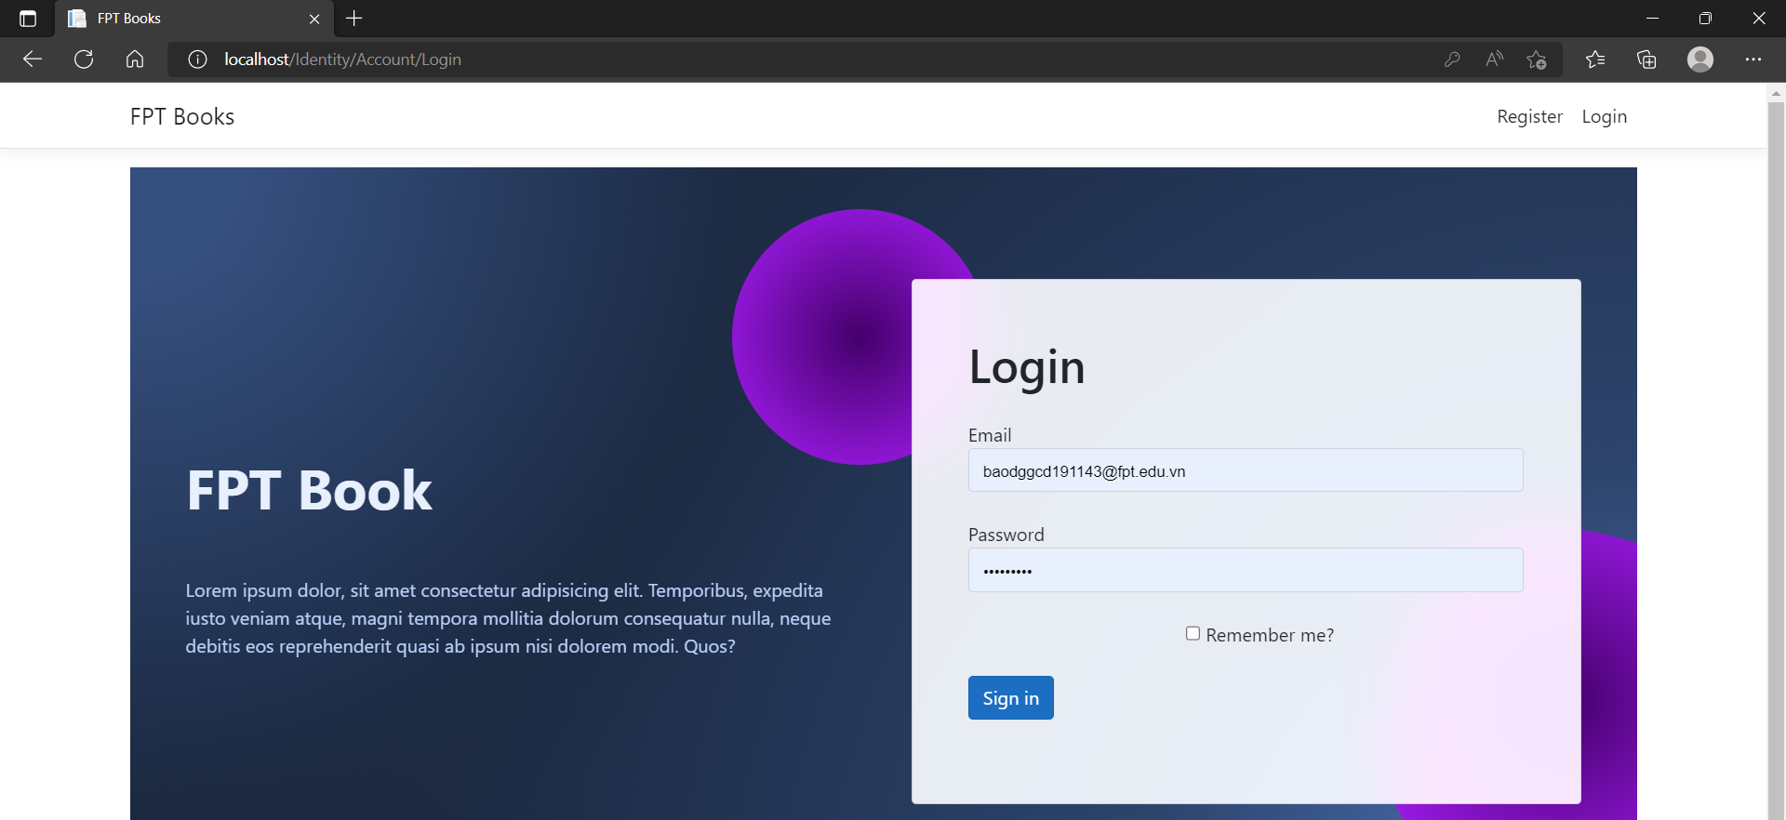

Figure 66: Deploy success

# Chapter 3 – Application Evaluation (P6 – M5)

### Application functionality.

#### Here are the features our app currently includes:

#### **For the customer role.**

#### - Registration screen where customer can register as a member and this page contains information fields to enter such as: email, Full Name, Password, Re-Password and Home Address.

#### - The default screen is the screen that asks the user to login or register. After logging in as a customer, the system will display all the products that can be purchased. In each product on the main screen, there will be 2 functions: view product details or add to cart. When the user chooses to view product details, the system will display detailed information about that product and there will be an add to cart button at the product detail page.

#### - Profile screen contains customer's account information and they can update their information like phone number, email....

#### - The Cart screen will display the products that have been added to the cart along with the price, quantity, and total amount. Here, there will be functions such as: delete products in the cart, edit quantity, view product details. Below will be the words 'Order Confirmation'

#### so that customers can view order details and make purchases.

#### - The all invoices screen will show the orders that the customer has purchased in the past. Customers can review or edit unconfirmed orders. In each product in the invoice, the user can click the button to view product details.

#### - Help screen to answer customer questions by topic such as: order policy, shipping or return...

#### - The search bar is placed above the navigation bar so that customers can search for books by title and genre.

#### **For the role of Owner Store**

#### - The Book screen allows store owners to perform product CRUD operations.

#### - The catalog management screen allows the store owner to send an administrative request when he wants to add a category that is not yet in the store.

#### - The recording screen allows the store owner to view the orders of all customers and when clicking to view order details, the system will display: Customer name, address, phone number, product name product, quantity, price, total amount.

#### **For the role of Admin**

#### - The Customer management screen allows administrators to access and change their password in case they lose their password.

#### - Store owner management screen allows Admin to have access and reset forgotten password of any store owner.

#### -The category management screen will give the admin the option to approve or deny the store owner's requests to add a category.

## Review the performance of the application.

### Application performance.

#### In order to be able to test the performance of the application, the following I will test the performance of a function in the system. The function that I selected is responsible for displaying all products when the customer successfully logs in.

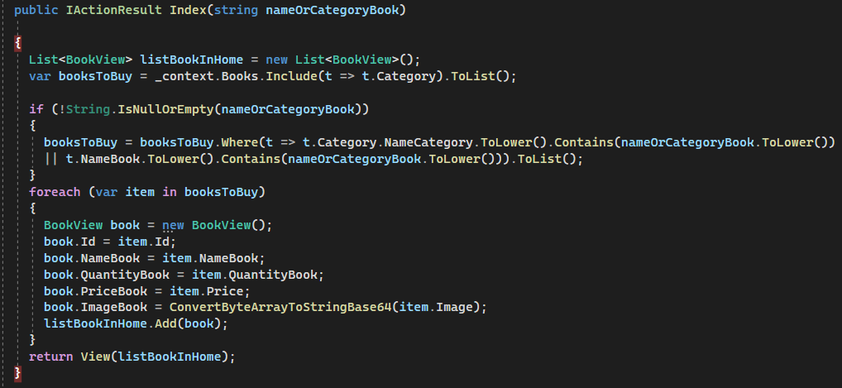

Figure 67: Application performance.

#### In order to be able to perform performance testing, I launched the application and when it reached the break point the system stopped so I could check function. After checking, I got a summary. First, we can see how much memory and CPU the application has used. Furthermore, 53 events took place when checking the index function and I took a Snapshot to check the difference in object and heap size before and after the index function worked.

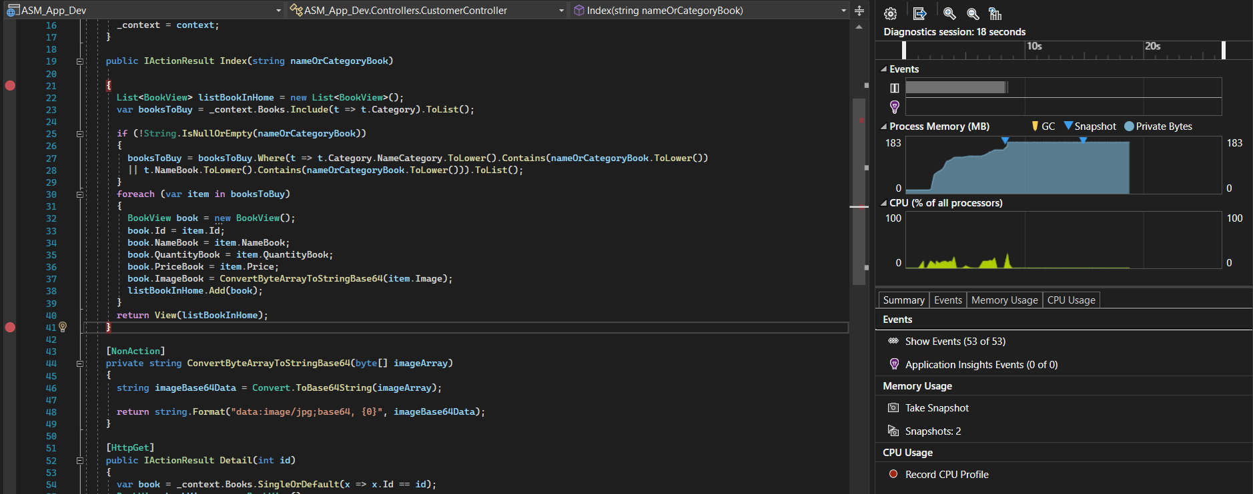

Figure 68: Result Application performance.

#### The following are some descriptions of the differences between before and after performing functional performance testing.

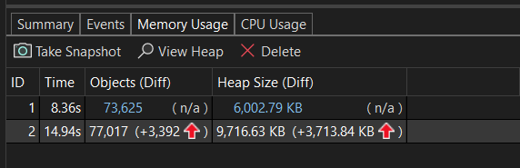

Figure 69: Result Application performance

#### This is detailed information of each event that took place in the function including time, duration of the process that took place and thread.

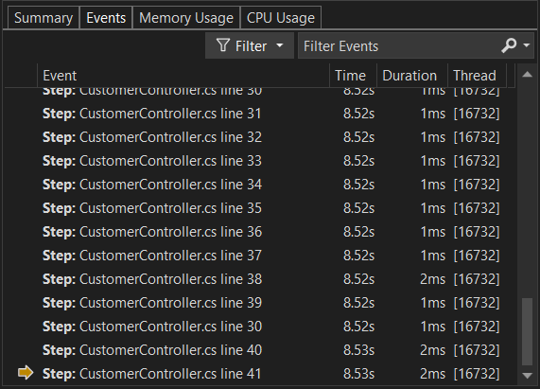

Figure 70: Result Application performance

#### Then, with the Diagnostic Tools, we can check the CPU Usage for running the app. We can see a list of functions in the CPU Usage view that are ranked by how long they have been running, with the longestrunning function appearing first under Top Functions. The call stack for the functions with the highest CPU usage is displayed to us in the Hot Path section.

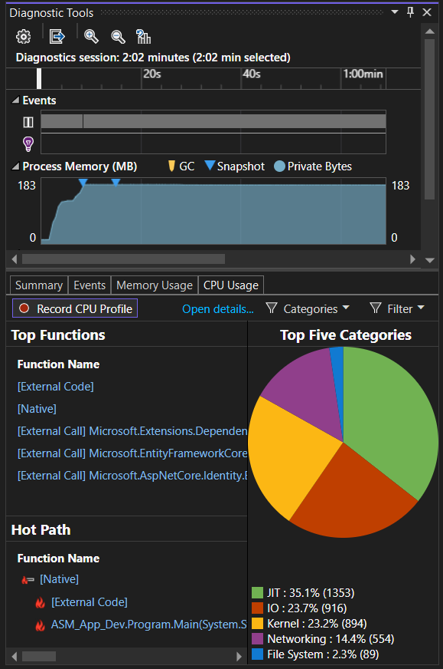

Figure 71: Result Application performance

#### Taking at least one memory snapshot, we can know the specific state of the system at a particular time.

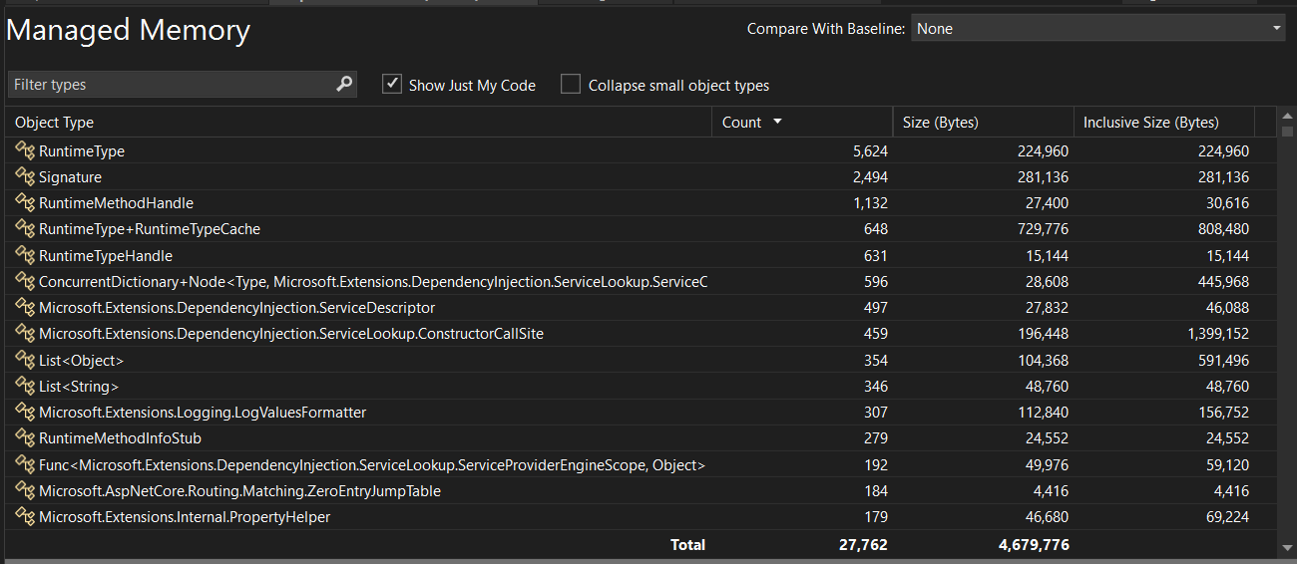

Figure 72: Result managed memory

## Conclude whether the application adapts all requirements or it needs to be improved later

|  |  |  |  |  |  |
| --- | --- | --- | --- | --- | --- |
|  | **Test case** | **How to do the test** | **Expected results** | **Result** | **Status** |
| 1 | Search product. | Login with customer account and enter product name to search (EX: ) | The system displays products according to the searched name. |  | **Pass** |
| 2 | View product details. | Login with customer account. I would then click on a product on the homepage to view detailed information. | The system goes to the product detail page and displays more information about the product. |  | **Pass** |
| 3 | Add product to cart. | Login with customer account. Then I will click on the add product to cart button | The system will add the products to the cart and display cart. |  | **Pass** |
| 4 | Edit quantity &Delete product in cart & make purchase. | After adding at least 2 products to the cart. I will increase the quantity to buy and delete any product and press the buy button to go to the checkout page and make the purchase. | The system will change the order status to processing and I can't edit it in the invoice list. |  | **Pass** |
| 5 | View all past order. | After making a purchase, I will click on the order list button to see the successful order. | The system will display the entire invoice and can view the order details. |  | **Pass** |

### Conclusion

#### **Advantages.**

#### The system has provided all the necessary functionality for the requirement. The function performed well on its task. Also, on the interface side we have tried to have an easy to see and simple interface.

#### **Disadvantages.**

#### The system has not yet done well with the task of securing user information. When registering or making a purchase, we have not yet sent a confirmation message. Also, we haven't dig deep into security techniques yet.

#### On the interface side, the interface is still not really good. When it comes to official business, customers will ask for more. The interface needs to be more beautiful to increase the feeling of experience for customers.

#### On the functional side, I think it is still not enough to serve the needs of customers. In the future I will update and add more functions such as product filtering, multi-language search.....

#### On the processing side of the algorithm, it will have a big problem when there is too much data to process. The system will become slower and more prone to crashes. The system will need to implement techniques such as: optimizing the algorithm, limiting requests to the database .....

## Analyse the factors that influence the performance of the application

### Factors that influence the performance of the app

#### **Poor coding standards**

#### The main factor that makes a big impact on website speed and performance is poor coding standards and practices. Unnecessary code blocks should not be added as it can hinder page speed a lot. Just by removing all unwanted or dead code, line breaks and spaces in the code can show a significant difference in site speed.

#### **Heavy use of CSS and JavaScript**

#### This is one of the most important factors affecting website performance. Common culprits of sluggish websites are CSS and JavaScript files that add functionality and style to a website's user interface. This is a specific issue when it occurs with above-the-fold content.

#### **Server / Hosting**

#### Website hosting provider has a huge impact on website performance. An online business that attracts a large amount of traffic or a website that requires a lot of data for things like video streaming or custom apps, a shared hosting won't cut it. there. Limited bandwidth and RAM will affect website performance. Make visitors have a bad experience.

#### **Algorithm complexity**

#### Algorithms don't make your code shorter, it even makes it longer. But efficiency is undisputed, algorithms help your program run faster, with optimization algorithms your program can run even faster. Therefore, when optimizing the algorithm and having fast processing time, it will bring a lot of advantages and greatly affect the performance of the website.

#### **Testing.**

#### Agile release cycles — the reality is that less than 5% of developers performance test their code before it is pushed to production. The “make it work” over “make it perform” mantra is one of the biggest factors that impacts application performance today. Most organizations don't have the time, resource or budget to replicate production environments in test for every agile release, this is why a growing trend of customers have started to test in production out of working hours. When you consider that the codebase of an application changes several times per month, you can begin to understand why performance anti-patterns and bottlenecks make their way into production.

#### **System Design.**

#### In my view, the biggest factor affecting application performance today is poorly optimized code and infrastructure, such as suboptimal SQL queries, configured network infrastructure, etc. poor graphics or inefficient coding algorithms at the application layer. All of these issues can be difficult to isolate, and an emphasis on DevOps processes can cause these problems to multiply rapidly by accelerating change in the data center. Therefore, it is important to provide the data center with adequate tools to monitor and report on all aspects of a deployed application using code level meters, EURT and network performance tools as well as traditional IT infrastructure monitoring solutions.

### Evaluations of the design, development, and testing phases of application.

#### **Review Design**

#### About the design, According to the folder structure of the project, we have divided the folders containing the files classified by function such as: Models, Views, Controllers, Data, DTOs, Views... However, our application has not really met the basic elements of the Model - View - Controller model. Our controller files still contain the source code that handles the algorithm. However in reality. As for the controller files, they are only responsible for transporting data. In addition, the algorithm that we apply to handle the logic is still quite simple and has not been optimized optimally. This will greatly affect the performance of the application.

#### **Review Development.**

#### The source code of our application still has a lot of development problems, We are not really experienced in algorithms and writing clean code. We are mainly focusing to run the functions. The performance of the application will suffer due to some clutter areas and longer runtime as the database grows over time.

#### **Review Testing Phases.**

#### We are still in the process of learning and testing automated application testing. Therefore, in this project we are applying manual testing method. When it comes to manual testing, mistakes in the testing of application features are inevitable. Furthermore, manual testing cannot be as detailed and accurate as automated testing. This can affect the performance of the application, especially for non-functional features.

### Conclude your assessment by reflectively discussing the previously identified risks.

#### After completing the project, we realized that the risks that we identified were not really good. We've identified a risk that a website has slow performance, but it's not enough for a project. We have also introduced risks to manage such as: faulty source code, not deployable. We forgot that there are a lot of things to keep in mind and control it like: performance, algorithms, system design.... Therefore, our website is only at a low level. After this project, I realized I needed to add more personal skills and knowledge.

# Chapter 4 - Evaluate any new insights, ideas or potential improvements to your system and justify the reasons why you have chosen to include (or not to include) them as part of this business application. (D1)

## Here are some ideas and potential improvement goals that I have picked up.

### Multi-language search, product filtering, saving multiple product photos and videos.

#### Multilingual search is a function that is being used and is included in the most popular websites that are used by many people. In our app only search by book genre or book title. However, to build a more professional website, this is an indispensable function. Multilingual search will help customers from different countries easily find the books they want. They will be very useful for organizations serving multinationals and make the website more useful and a better experience for everyone.

#### For a website that stores a lot of images and videos of the product, it will help customers have a better experience during use. Usually, when a customer wants to buy a certain product. They will search and view product details. If the website has this function, the business of the organization will become more convenient. Verifying this is the product to look for will motivate customers to order more.

### ReactJS, lazy loading. Use cache.

#### React specializes in helping developers build user interfaces (UIs). This is the framework that helps the website to have more interaction with customers as well as its users. The website we are developing uses only a little bit of javascript. For a better experience reactJS is a great recommendation.

#### Lazy loading is a design pattern suggested in the survey response. It helps the website performance to work better and faster. For our website, when it's load all images will be uploaded at once. This will reduce the performance and increase the loading time of the website. To increase performance, lazy loading will load the content when the user views it. For example, if a website has 100 products, lazy loading will make the website display only 10 products first. The remaining 90 products will be displayed as the user scrolls down to see more.

#### Whenever content is downloaded from the origin server, a copy is stored in the web cache for a certain period of time determined by the caching rules you have installed. When multiple users re-request the same content, the web cache sends this previously cached content, so the user's requests don't need to be sent further to the origin server. And we can understand this activity as content caching. This will also make the website performance stronger and provide a better experience for customers.

### Refactor the source code.

#### Currently, in our application, we are writing the algorithm code in the controller directory. This is absolutely not true because the goal is a file that performs a task. In the future we will cut the algorithm source code and put them in the repository directory. Then the file controllers will call them to process the data. This will also benefit code reuse.

## Explain why I chose to include (or not include) them as part of the application.

#### We are currently 3rd year students. We have learned and have some knowledge about .Net and C#. However, for other developers, we are really too inexperienced to develop a comprehensive system in all respects. In this project, we spent most of our time researching techniques and technologies to apply them to the project. Therefore, what prevents us from accessing the ideas and innovations above is experience and knowledge. In addition, our time on this project is only one month. We couldn't do better than expected. However, in the future, we will update the project and make it a better serviceable and more comprehensive product.

# Chapter 5 - Critically evaluate the strengths and weaknesses of your business application and fully justify opportunities for improvement and further development. (D2)

## Strengths of the application.

### The application responds to requests from customers.

#### At the request of customers. Our application has provided all the necessary and basic functionality of the roles. The database design process and MVC pattern implementation are tightly managed and ensure that the files are organized according to the norm. The handling system and functions work well. Limit errors and application crashes.

### Security of personal information is quite good.

#### In our application used password encryption method. This will help customers secure their passwords and personal accounts.

### The simple interface fits the requirements.

#### Our application interface is designed with simplicity in mind. Wireflow is designed according to regulations and according to a specific rule. Therefore, when using, users can easily access the application without having to spend too much time getting used to it. Buttons, product information are arranged and displayed in a scientific way and are mostly applied in e-commerce websites.

### Deploy website successfully.

#### For a software. If only usable in development device. It is not called a live software. The most important and also the key to confirm that the software has really succeeded lies in the deploy step. In this project we have successfully deployed the website in IIS Server and Microsoft SQL Server. We also tested the website using a wifi router for computers and using the website on mobile devices.

## Weaknesses of the application.

### Few functions.

#### The functions that the website owns are only basic functions and easy to implement. Website is lacking the necessary functions for users such as: product filtering, multi-language search, chat box.... To be able to put the website into a business organization, it is necessary to develop more functions. . When using a comprehensive website in all aspects and good user support, customers will be impressed with the organization and the rate of returning to buy products is very high.

### Low performance.

#### Our website is currently dealing with a lightweight database. This will help the website perform well. However, what we are concerned about is when the database swells. The website will be difficult to handle and prone to crashes or unresponsiveness. The problem comes from many sides. But what we are really worried about is that the source code is not really neat and smart. Our source code has a lot of redundant code.

### Can't make online payment.

#### For an online sales website and the lack of online payment features is an unacceptable problem. Offline payments will greatly hinder the organization's business. All websites and apps today use this feature. Users are also very supportive of online payments because of its convenience and faster than traditional methods.

## Fully justify opportunities for improvement and further development.

### .NET and C# have large user communities and good problem solving methods.

#### Currently, most software and websites use c# and .net programming languages. Because this language has a lot of advantages as well as clear paths that Microsoft has shown and with Microsoft providing a lot of documentation. This has made C# as well as .Net dominate the market. The large number of users will support me a lot in the process of building the project and also looking for a solution to handle the problem. Therefore, in the future our project will be updated and further developed is an extremely easy thing.

### Practical application suitable for many organizations.

#### For an online business application like ours, organizations are looking for it nowadays. This will give us more opportunities to access good technologies and techniques and serve as a foundation to develop ourselves and this project.